

Capstone Project Report
Report 6 – Software User Guides

– Hanoi, August 2019 –
Table of Contents
I. Project Report 3
1. Status Report 3
2. Team Involvements 3
3. Issues/Suggestions 3
II. Release Package & User Guides 4
1. Deliverable Package 4
1.1 Source codes & documents 4
1.2 Known Issues, Limitations & Restrictions 4
2. Installation Guides 4
2.1 System Requirements 4
2.2 Setup Files 4
2.3 Installation Instruction 4
3. User Manual 4
3.1 Terms and definitions 4
3.2 System requirements 4
3.3 Application Usage 5
3.4 Troubleshooting 5

I. Project Report

Team Involvements
# | Task | Member | Notes (Task Details, etc.)
 | Overview | TinTT
 | Management Approach | HungLH
 | Master Schedule | HieuTH
 | Responsibility Assignments | KhangLTV
 | Project Communication | KhangLTV
 | Configuration Management | KhaTM

II. Release Package & User Guides

1. Deliverable Package

1.1 Source codes & documents
No. | Items | Sub-Items | Type | Version
Code Package
1 | Skinsense | Skinsense Web-based application | New | 1.0
 |  | Skinsense mobile application | New | 1.0
2 | Clinic managerment | Skinsense API | New | 1.0
3 | Goolge could server | AI detection API | New | 1.0
Database
1 | Tables | Clinic_kl.sql | New | 1.0
Documents
1 | Report 1 |  | New | 1.0
2 | Report 2 |  | New | 1.0
3 | Report 3 |  | New | 1.0
4 | Report 4 |  | New | 1.0
5 | Report 5 |  | New | 1.0
6 | Report 6 |  | New | 1.0
7 | Report 7 |  | New | 1.0

1.2 Known Issues, Limitations & Restrictions
- The system only works when the servers are up.
- The system requires an Internet connection.

2. Installation Guides

2.1 System Requirements
For server:
- Operating system: Ubuntu 20.04
- Interpreter/compiler: Python 3.9, .NET 6, Ultralytics 8.0.151
- Storage: 64 GB NVMe
- RAM: 2GB or higher
- CPU: XEON 1 vCPU
- Database: SQL Server
- Docker 24.0.5
- Nginx 1.24.0
- Nodejs 18.17.1
For web client:
- Operating system: Windows 10, macOS 10.13
- Browser: Google Chrome 90, Safari 14.0.3 (macOS), Safari 14 (iOS), Microsoft Edge 89.0 or newer.
For mobile application client:
- Operating system: Android 12 or higher.

2.2 Setup Files
- Clinicapp.apk

2.3 Installation Instruction
- Install Visual Studio 2022
To download Visual Studio, visit the official website at (https://visualstudio.microsoft.com/). Go to the "Downloads" section and find the version you want, such as Visual Studio 2022. Click the "Download" button.
Once the download finishes, run the installer file. This will open the Visual Studio Installer, which will guide you through the installation process.
During installation, you'll be asked to choose workloads. Workloads are customized sets of tools for specific types of development. Pick the ones that match your needs, like programming languages and platforms you use.
You can also select individual components you might need for your work, like libraries and frameworks.
You'll have the option to change where Visual Studio is installed on your computer if needed, though the default location is usually fine.
Once you're ready, hit the "Install" button. The installer will download and install the chosen components. This might take some time depending on your internet speed and selections.
After the installation is done, you can launch Visual Studio from the Start menu or desktop shortcut. If necessary, sign in with your Microsoft account or create one.
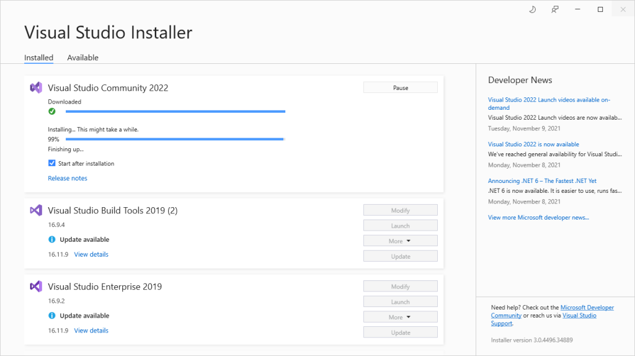
Figure 1. Visual studio installer

- Install Visual Studio Code 2022
Download Visual Studio Code:
Visit the official Visual Studio Code website (https://code.visualstudio.com/) and navigate to the "Downloads" section. Download the appropriate version of Visual Studio Code for your operating system (Windows, macOS, or Linux).
Run the Installer:
Once the installer file is downloaded, run it to begin the installation process. Follow any on-screen prompts to proceed.
Choose Installation Options (if applicable):
Depending on the version and your operating system, you might be presented with some installation options. These could include things like adding VS Code to your PATH or creating desktop shortcuts. Adjust these options according to your preferences.
Install Visual Studio Code:
Proceed with the installation by clicking the necessary buttons to confirm your choices. The installer will copy the necessary files and set up VS Code on your computer.
Launch Visual Studio Code:
After the installation is complete, you can launch Visual Studio Code. It usually creates a shortcut on your desktop or in your applications menu. Open VS Code by clicking on this shortcut.
Install Extensions (Optional):
Visual Studio Code supports a wide range of extensions that add additional functionality and support for different programming languages and tools. You can explore and install extensions from the VS Code Marketplace by clicking on the Extensions icon in the sidebar.
Start Coding:
Once Visual Studio Code is open, you can start coding by creating or opening a project folder. Use the built-in file explorer and editor to write and manage your code.
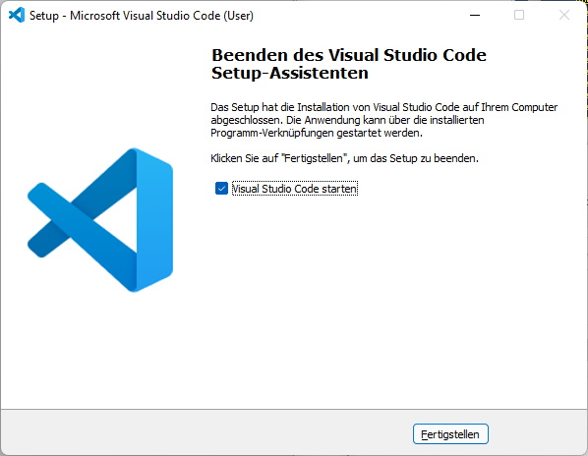
Figure 2. Visual studio code installer
- Install SQL Server 2022
Download SQL Server Installer:
Go to the official SQL Server website (https://www.microsoft.com/en-us/sql-server/sql-server-downloads) and find the "Downloads" section. Locate the version of SQL Server you wish to install (e.g., SQL Server 2022 when it becomes available) and click on the "Download" button.
Run the Installer:
Once the installer file is downloaded, run it. This will launch the SQL Server Installation Center, which will guide you through the installation process.
Choose Installation Type:
SQL Server provides various installation types, such as Basic, Custom, or Download Media. Pick the one that suits your requirements. If you opt for Custom, you can select specific features to be installed.
Accept License Terms:
Review and agree to the license terms to proceed with the installation.
Choose Instance Type:
You'll be asked to select the instance type, either Default or Named. If you choose Named, you can specify the instance name.
Specify Installation Location:
Decide on the installation location for SQL Server. You can stick with the default path or set a custom one.

Configure Server and Instance Settings:
Depending on the chosen instance and type of installation, you may need to configure various settings like authentication mode, collation, and more.
Configure Database Engine:
When installing the Database Engine, you'll need to set up database-specific configurations, such as authentication settings and data directories.
Install Features:
Depending on your needs and installation type, you can choose to install different features like Database Engine, Analysis Services, and Reporting Services.
Configure Additional Components (if needed):
If your needs require it, you may need to configure additional components like Reporting Services, Integration Services, and Analysis Services.
Review Summary:
Take a moment to review the summary of your installation choices and configurations. Make sure everything aligns with your intentions.
Start Installation:
Click the "Install" button to kick off the installation process. The installer will copy files, configure settings, and install the selected SQL Server components.
Completion and Configuration:
Once the installation concludes, you might need to carry out some post-installation tasks, such as configuring security settings and setting up database accounts.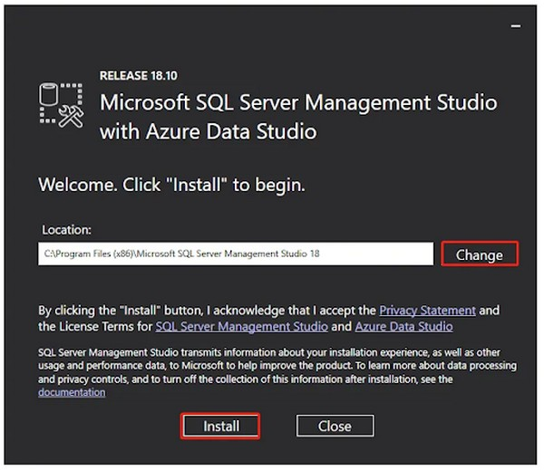
Figure 3. SQL server installer
- Install Nodejs 18.17.1
Download Node.js Installer:
Visit the official Node.js website (https://nodejs.org/) and navigate to the "Downloads" section. Find the version of Node.js you want to install (e.g., Node.js 18.17.1 if it's available) and download the appropriate installer for your operating system (Windows, macOS, or Linux).
Run the Installer:
Once the installer is downloaded, run the executable file on your operating system.
Choose Installation Options (if applicable):
The Node.js installer might provide you with installation options. These could include things like adding Node.js to your system PATH or including npm (Node Package Manager) during the installation. Adjust these options according to your preferences.
Install Node.js:
Proceed with the installation by clicking the necessary buttons to confirm your choices. The installer will copy the necessary files and set up Node.js on your computer.
Verify Installation:
After the installation is complete, open a command prompt or terminal and type the following commands to verify that Node.js and npm (Node Package Manager) are installed:
node -v
npm -v
These commands should display the installed versions of Node.js and npm respectively.
Using a Specific Node.js Version (if necessary):
If you need to switch between different versions of Node.js on your system, you can use a version manager like "nvm" (Node Version Manager) for Unix-based systems or "nvm-windows" for Windows. These tools allow you to manage and switch between multiple Node.js installations.
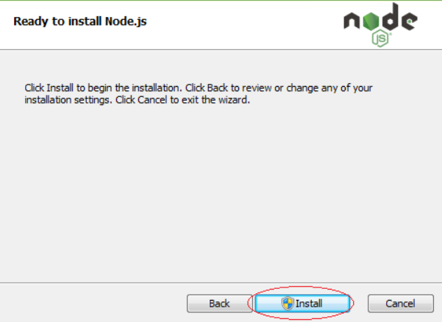
Figure 4. Nodejs installer

- Install Docker 24.0.5
Download Docker Installer:
Visit the official Docker website (https://www.docker.com/) and navigate to the "Get Docker" section. Find the version of Docker you want to install (e.g., Docker 24.0.5 if it's available) and download the appropriate installer for your operating system (Windows, macOS, or Linux).
Run the Installer:
Once the installer is downloaded, run the executable file on your operating system.
Follow Installation Steps:
The installation process might vary based on your operating system. Follow the on-screen instructions to install Docker. This may include accepting license agreements, choosing installation options, and configuring Docker settings.
Start Docker Service:
After installation, Docker should automatically start as a service on your computer. In some cases, you might need to manually start the Docker service. Refer to the documentation for your specific operating system for instructions on how to start Docker.
Verify Installation:
Open a command prompt or terminal and type the following command to verify that Docker is installed and running:
docker --version
This command should display the version of Docker that you installed.
Start Using Docker:
With Docker installed and running, you can now start using it to create and manage containers. You can run containerized applications, pull and push Docker images, and more.

Figure 5. Docker installer

3. User Manual

3.1 Terms and definitions
No | Term and definition | Description
1 | Patient | All users in the system, including administrator, academic department, student, teacher, and head of department.
2 | Administrator | An user who has the role of administrator and is allowed to manage user accounts of the system.
3 | Doctor | An user who has the role of academic department and is responsible for managing classes, modules, exams,...
4 | Staff | An user who has the role of student and is allowed to take exams, and view their mark report.

3.2 System requirements
For server:
- Operating system: Ubuntu 20.04
- Interpreter/compiler: Python 3.9, .NET 6, Ultralytics 8.0.151
- Storage: 64 GB NVMe
- RAM: 2GB or higher
- CPU: XEON 1 vCPU
- Database: SQL Server
- Docker 24.0.5
- Nginx 1.24.0
- Nodejs 18.17.1
For web client:
- Operating system: Windows 10, macOS 10.13
- Browser: Google Chrome 90, Safari 14.0.3 (macOS), Safari 14 (iOS), Microsoft Edge 89.0 or newer.
For mobile application client:
- Operating system: Android 12 or higher.

3.3 Application Usage

3.3.1. Overview
Our system has 4 roles (administrator, patient, doctor, staff). All the users have all of the following features:
- Login
- Logout
- Forgot password
An Administrator is the actor who can perform all of the following features:
- View patient.
- Management employee.
- Management medicine.
- Management room.
- Management treatment
A patient is the actor who can perform all of the following features:
- Login
- Register
- Forgot password
- Email verification
- Profile
- Edit profile
- Invoice
- Details invoice
- Medical record
- Test result AI
- Scan AI detection acne
- Appointment
- Cancel appointment
- News
A doctor is the actor who can perform all of the following features:
- View appointment.
- The patient examined.
- Medical record.
- Test result AI.
- Profile.
- Edit profile.
- Email verification.
- Reset password.
A staff is the actor who can perform all of the following features:
- Management news.
- Checkout invoice.
- Management appointment.
- View patient.

3.3.2. Skinsense in web-based application
- Login
- Triggering a function: user enters the website path https://clinicskinsense.com. and get into “login” page.
- Description of the function: all users can access the login page and use all the functions according to the assigned role of that account.
- Details of the function:
  - Normal execution case: after successful login the user will be redirected to the homepage depending on the role of the account provided (figure 8).
  - Abnormal excution case:
    - If you leave the email and password blank and enter the wrong email and password, the error message "Invalid Email or password" will be displayed (figure 9).
- Layout of the screen:
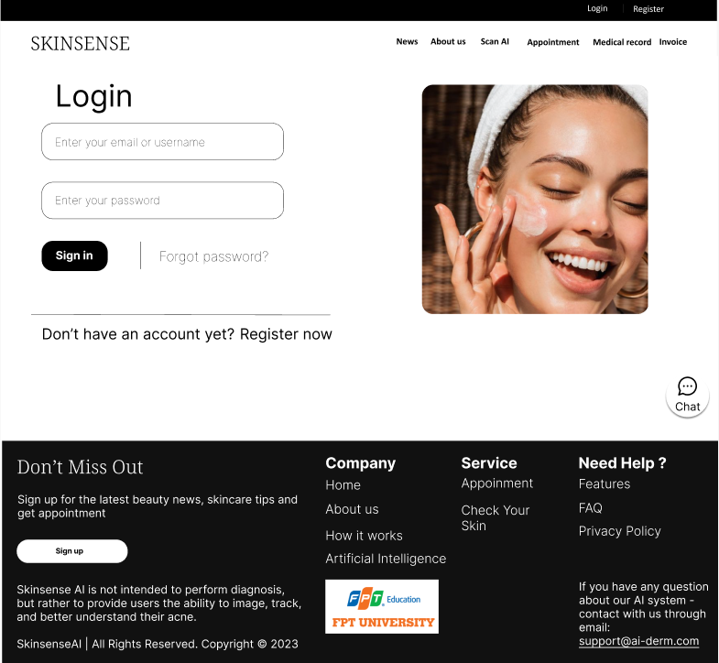

Figure 8. Login page
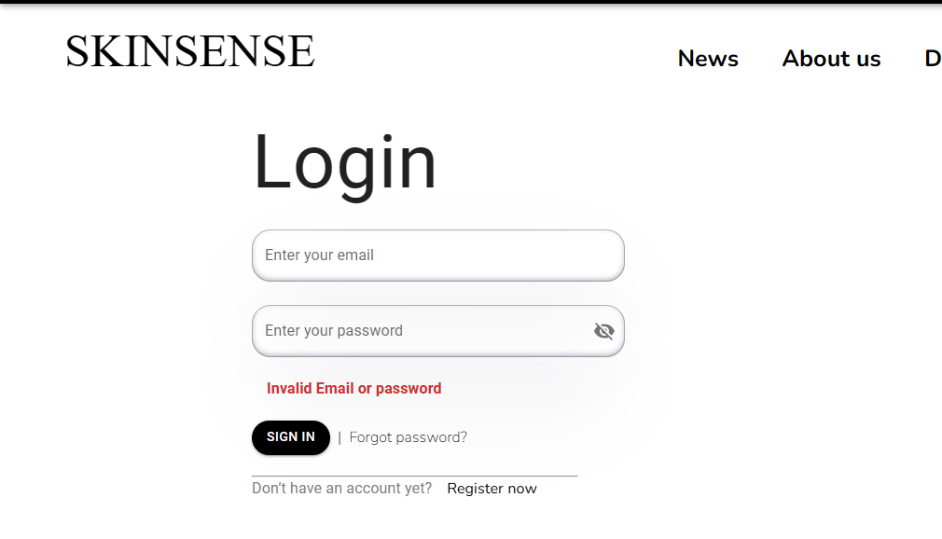
Figure 9. Validate login
- Logout
- Triggering a function: user enters the website path https://clinicskinsense.com. and get into “login” page, it will show the “logout” button right behind avatar on header.
- Description of the function: allow user logout from the system and redirect to the home page.
- Details of the function:
  - Normal execution case: after successful logout the user will be redirected to the homepage (figure 10).
  - Abnormal excution case:
    - Loss of connection
- Layout of the screen:


Figure 10. Logout button

- Forget password
- Triggering a function: user enters the website path https://clinicskinsense.com. and get into “login” page, it will show the “forget password” button right behind “sign in” button.
- Description of the function: allows users to recover passwords
- Details of the function:
  - Normal execution case: after the password has been recovered, the user will be redirected to the login page for the user to log in again (figure 11).
  - Abnormal excution case:
    - Users who enter an empty field will display the message "Please enter a valid email address!" (figure 12).
    - Users who enter the wrong email will display the message "Please enter a valid email address!"

    - Loss of connection
- Layout of the screen:
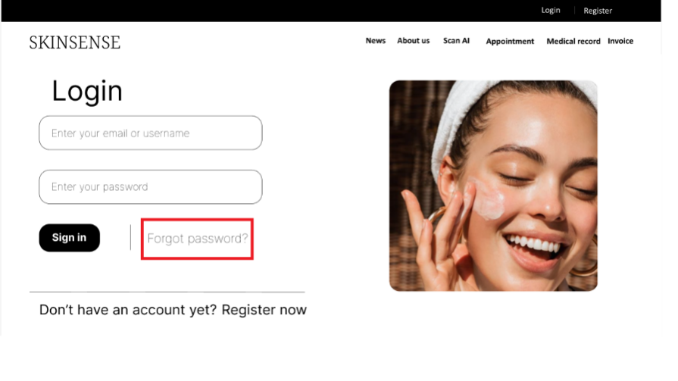
Figure 11. Forgot password button
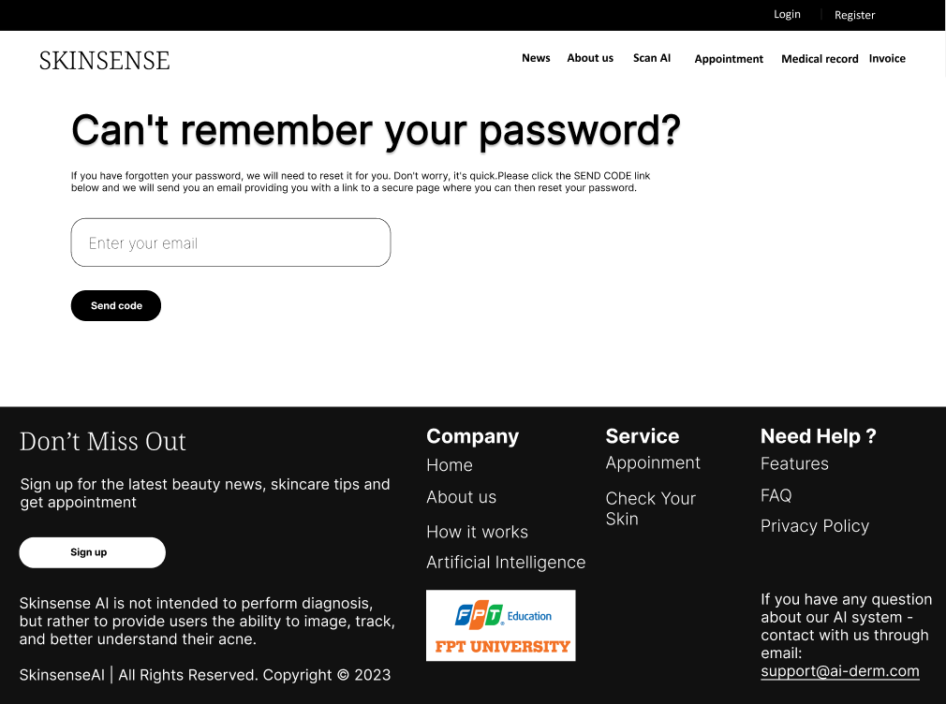
Figure 12. Forget password step 1
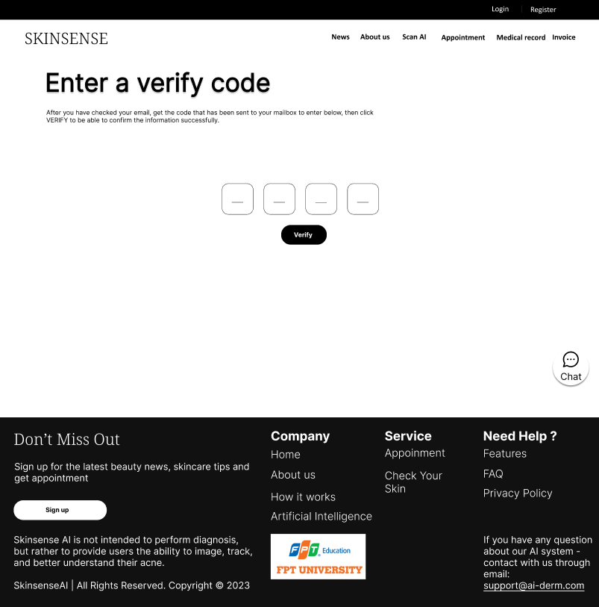

Figure 13. Forget password step 2
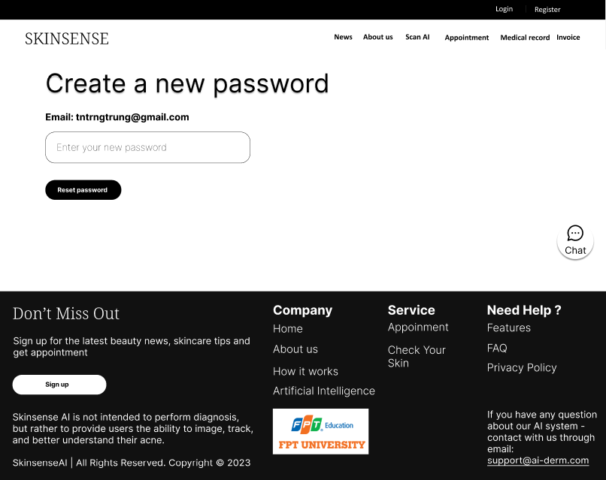

Figure 14. Forget password step 3
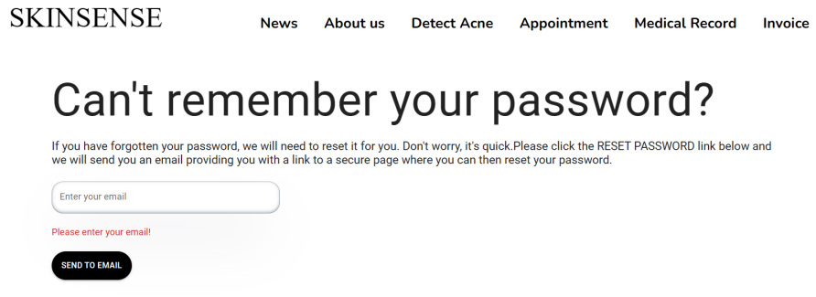
Figure 15. Validate empty in forget password step 1
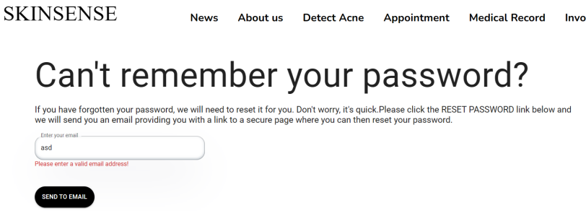
Figure 16. Validate format in forget password step 1
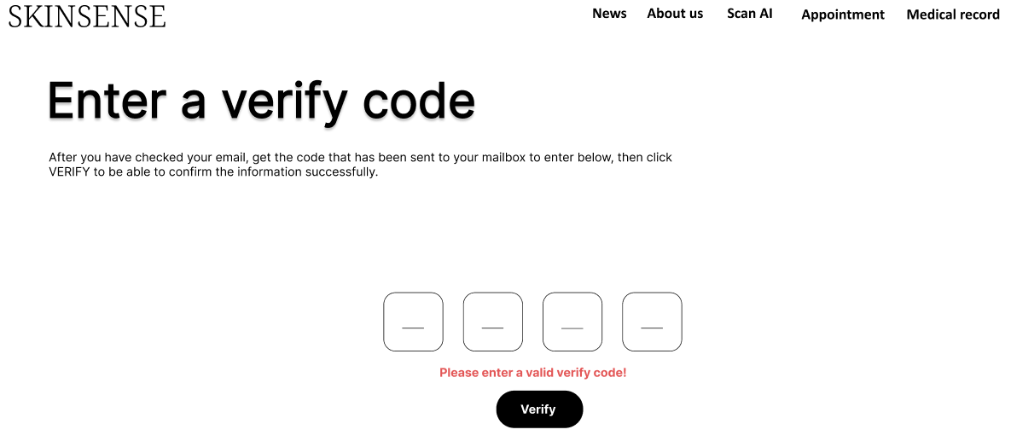
Figure 17. Validate valid verify code in forget password step 2
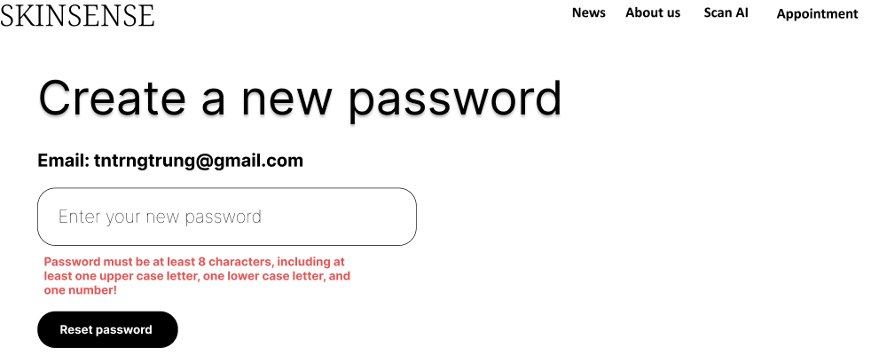
Figure 18. Validate valid password in forget password step 3
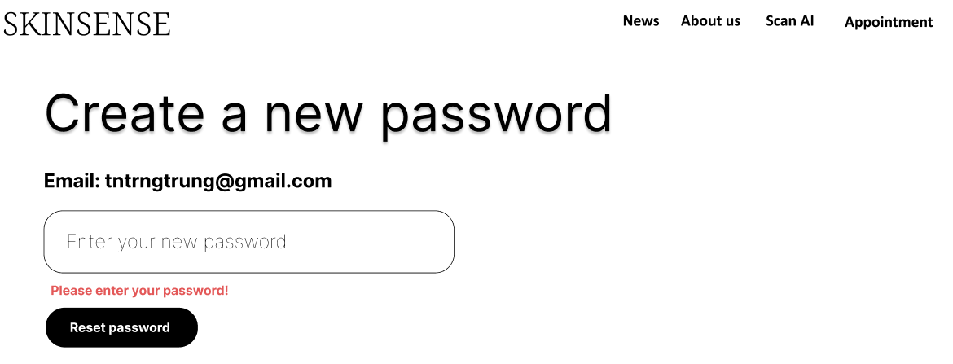
Figure 19. Validate empty password in forget password step 3

- Register
- Triggering a function: user enters the website path https://clinicskinsense.com. and get into “register” page.
- Description of the function: allows users create a new account.
- Details of the function:
  - Normal execution case: after successfully registering an account, the user will be redirected to the homepage that has been logged in with the newly created account (figure 20).
  - Abnormal excution case:
    - Users who enter an empty field will display the message "Please enter a valid value!" (figure 22).
    - Users who enter the wrong verify code will display the message "Please enter a valid verify code!"
    - If the user enters the wrong email format, enters the wrong password format, and does not match the new password, error messages will be displayed (figure 23).
    - Loss of connection
- Layout of the screen:
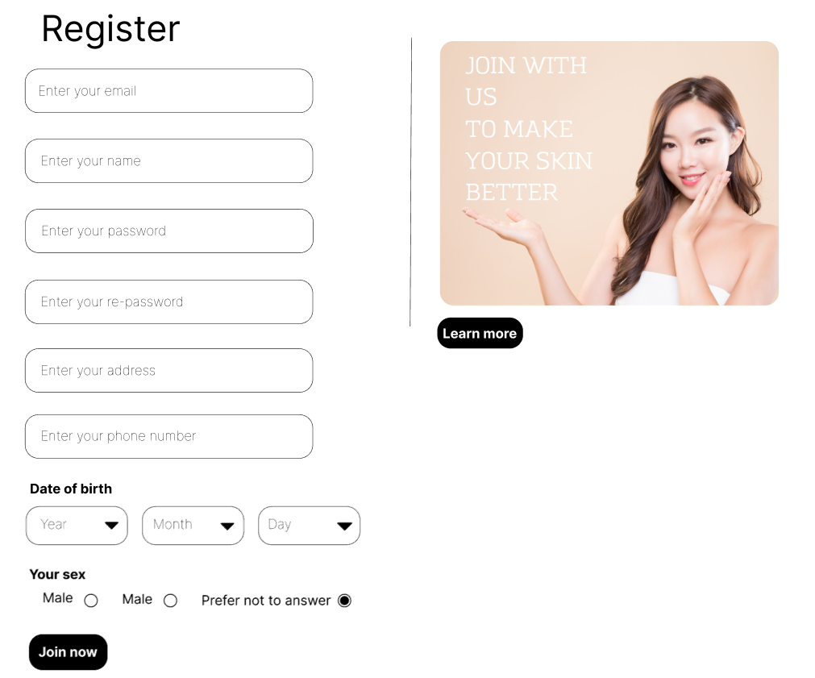

Figure 20. Register page
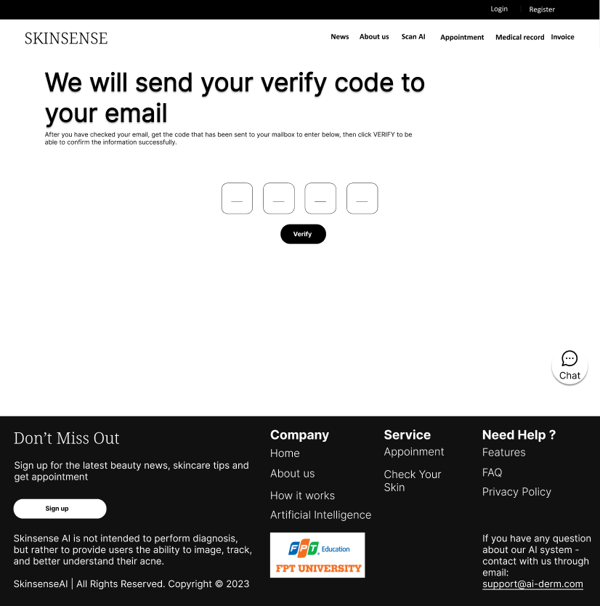

Figure 21. Verify email in register page

Figure 22. Validate empty in register page

Figure 23. Validate value in register page
- Profile
- Triggering a function: user enters the website path https://clinicskinsense.com. and login into the website then you click on the avatar image to go “profile” page.
- Description of the function: allows users to view their account profile and modify the information as needed
- Details of the function:
  - Normal execution case:
    - after logged in users can go directly to the "profile" page to be able to view their own profile information.
    - After successfully editing the information and click a button “save”, a pop-up "update success" will be displayed (figure 24).
  - Abnormal excution case:
    - When editing the profile fails and click a button “save”, a pop-up message "update failed" will be displayed. (figure 26).
    - When the user enters an empty field, an error message will appear (figure 27)
    - If the user enters the wrong email format, enters the wrong password format, and does not match the new password, error messages will be displayed (figure 28).
    - Loss of connection
- Layout of the screen:

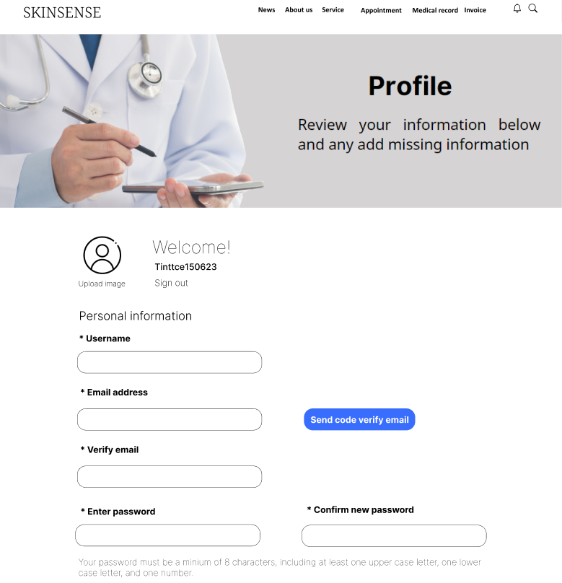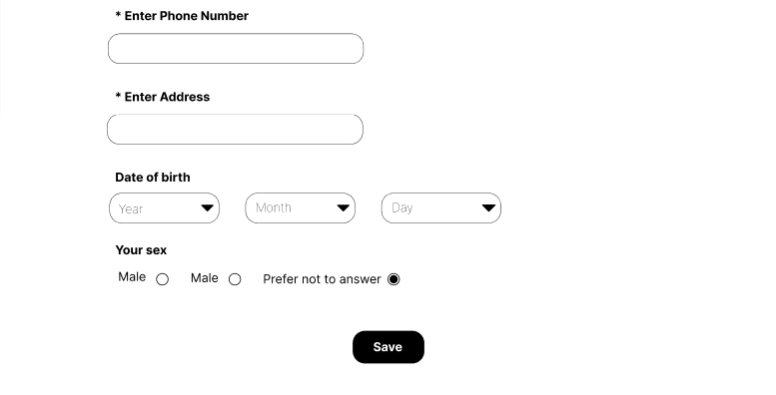

Figure 24. Profile page

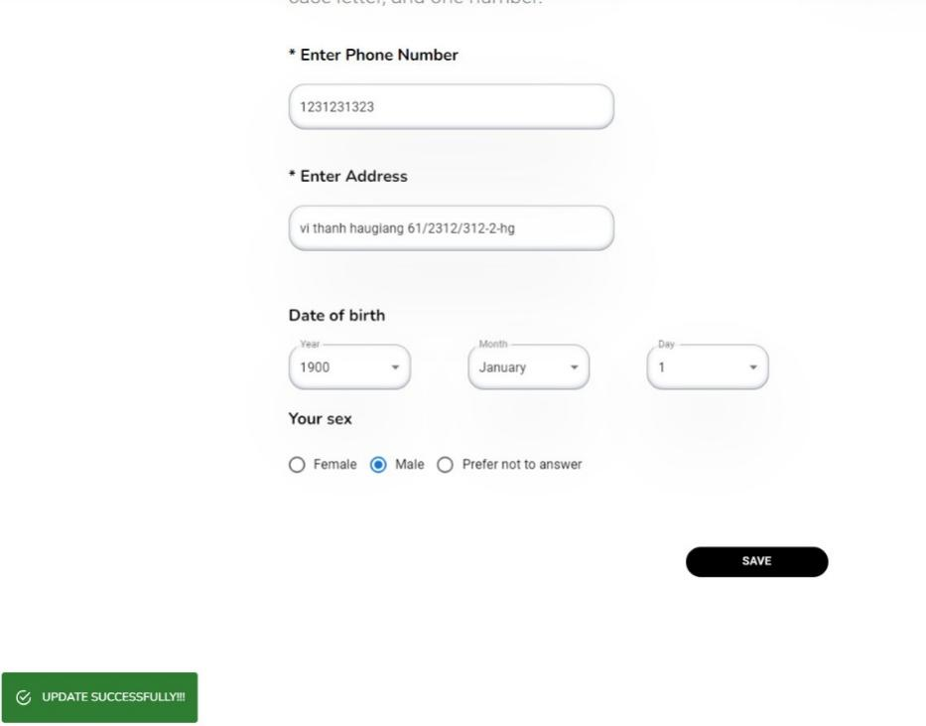
Figure 25. Success saving in edit profile
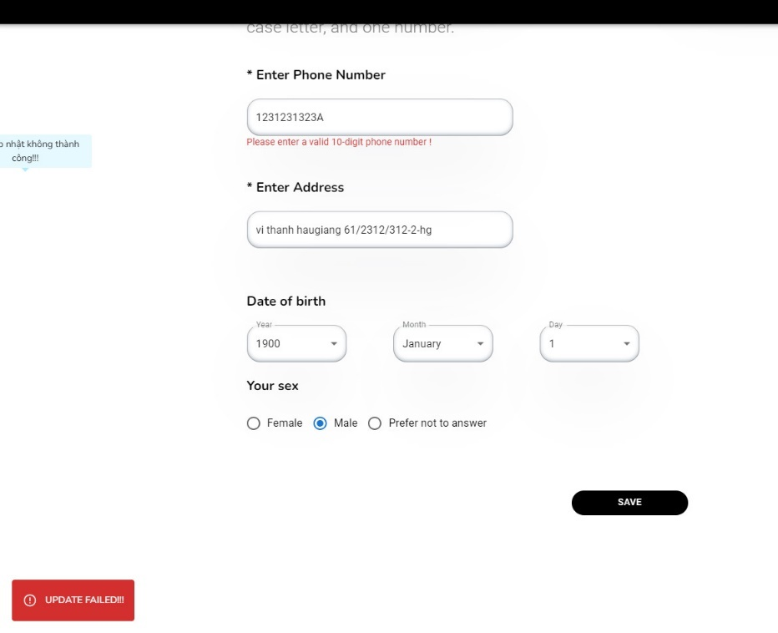
Figure 26. Failed saving in profile page
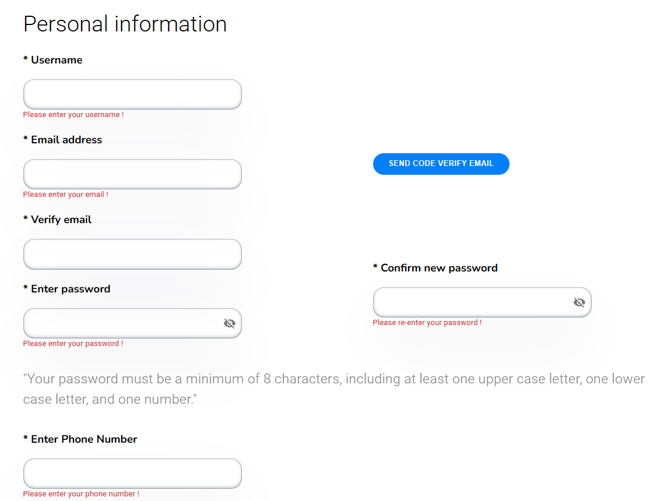
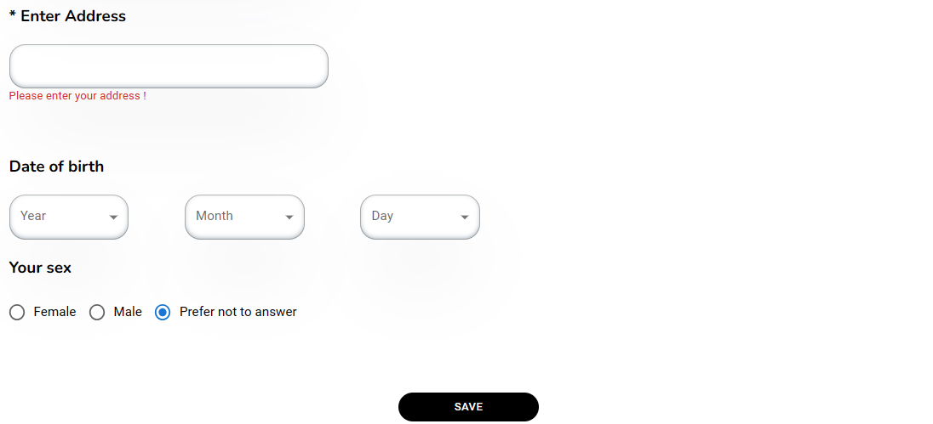
Figure 27. Validate empty in profile page
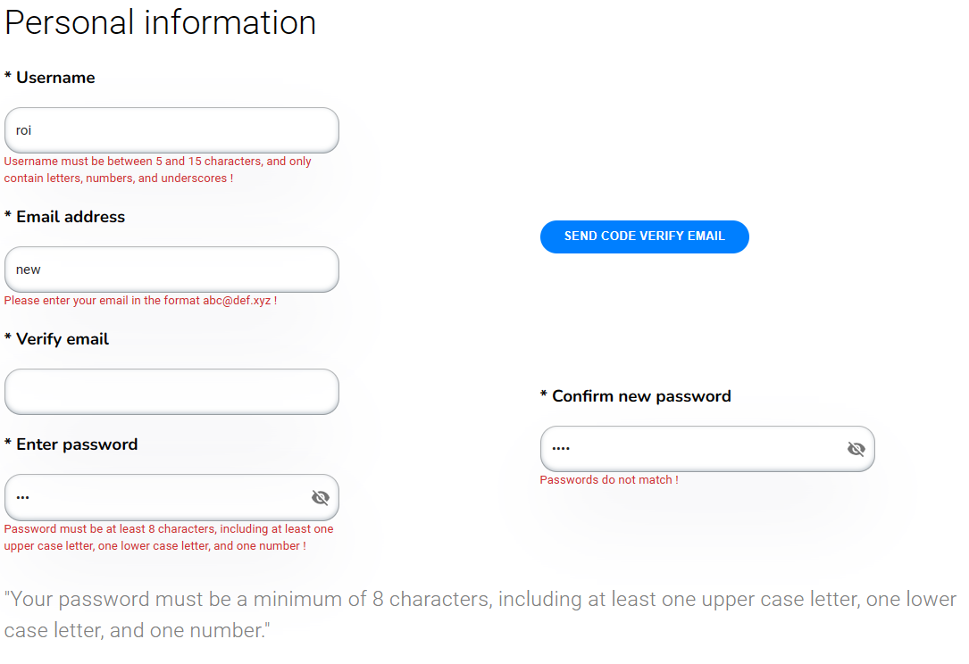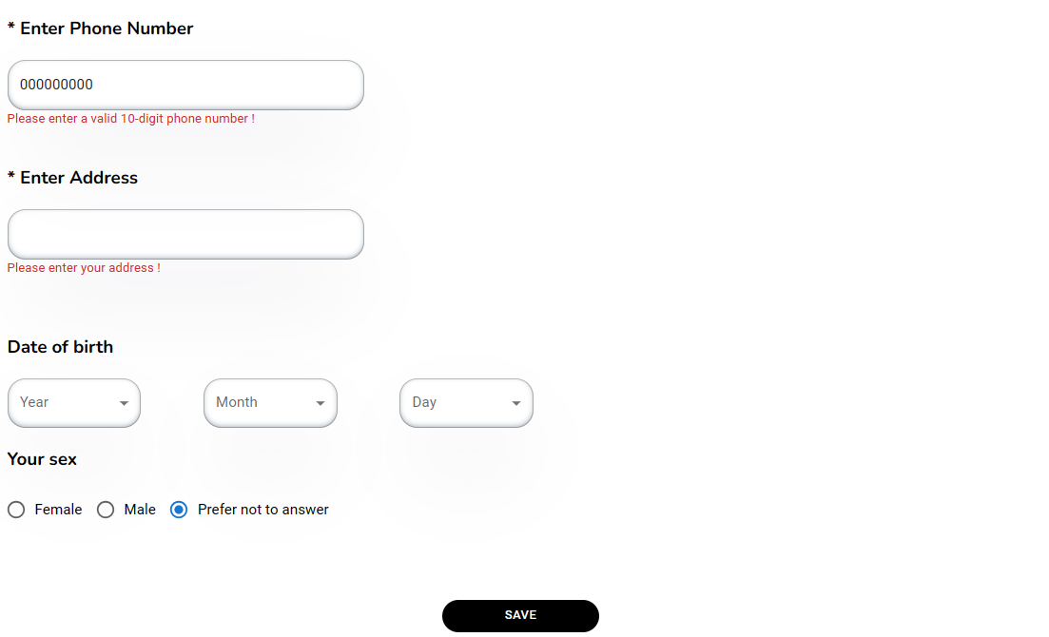
Figure 28. Validate valid in profile page

- About us
- Triggering a function: user enters the website path https://clinicskinsense.com. and click into “about us” button
- Description of the function: allows all users to view the information of about us page.
- Details of the function:
  - Normal execution case:
    - User can know more about website information (figure 29).
  - Abnormal excution case:
    - Loss of connection
- Layout of the screen:



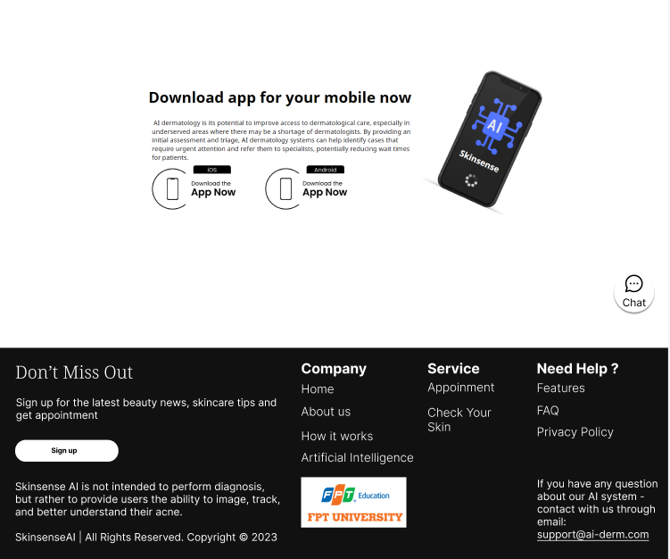

Figure 29. About us page

- Details invoice
- Triggering a function: user enters the website path https://clinicskinsense.com. Then user login as role as patient and click into “invoice” button
- Description of the function: patient can see the invoice generated by the doctor and the details of the invoice.
- Details of the function:
  - Normal execution case:
    - The user can see the list of invoices (figure 30, figure 31).
  - Abnormal excution case:
    - If the user does not have an account, the invoice will not be displayed (figure 32).
    - Loss of connection.
- Layout of the screen:

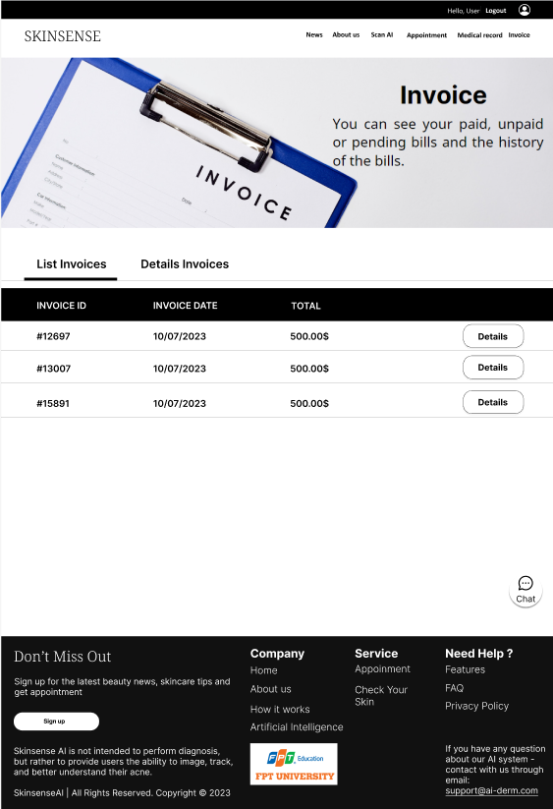

Figure 30. List of invoice in invoice page
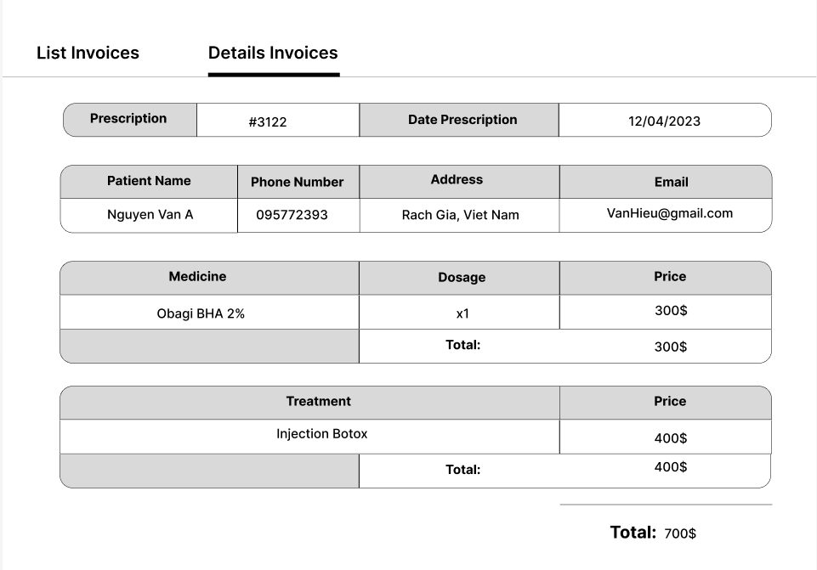
Figure 31. Details invoice in invoice page
- Medical record
- Triggering a function: user enters the website path https://clinicskinsense.com. Then user login as role as patient and click into “medical record” button
- Description of the function: patient can see the medical record generated by the doctor and the details of the medical record. Moreover, Medical records will be divided into two types: Report From AI and Report From Doctor.
- Details of the function:
  - Normal execution case:
    - The user can see the list of medical record (figure 33).
    - The user can see details of medical record as report from doctor (figure 35).
  - Abnormal excution case:
    - User will be created medical record by doctor and if it is not created by doctor then it will not be displayed (figure 32).
    - Loss of connection.
- Layout of the screen:
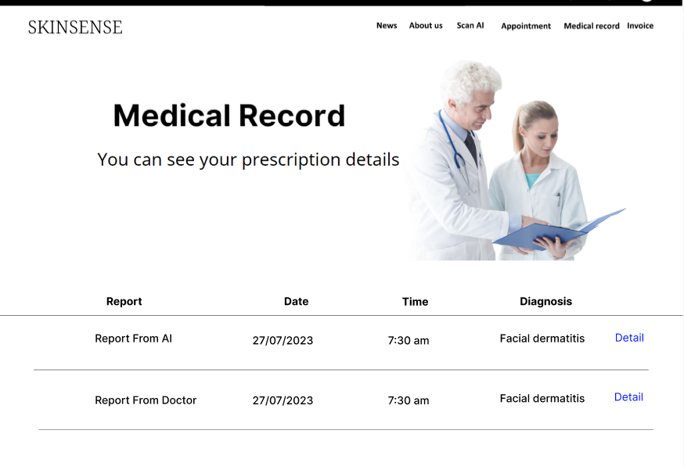

Figure 32. List of medical record in medical record page

Figure 33. Empty medical record in medical record page

Figure 34. Details medical record in medical record page
- Test Result
- Triggering a function: user enters the website path https://clinicskinsense.com. Then user login as role as patient and click into “medical record” button
- Description of the function: patient can see the medical record generated by the doctor and the details of the medical record. Moreover, Medical records will be divided into two types: Report From AI and Report From Doctor.
- Details of the function:
  - Normal execution case:
    - The user can see details of medical record as report from AI (figure 36).
  - Abnormal excution case:
    - Loss of connection.
- Layout of the screen:

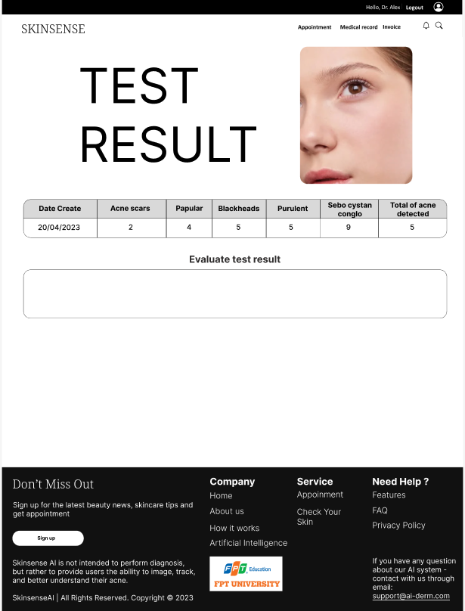
Figure 35. Test result page
- Scan AI Detection Acne
- Triggering a function: user enters the website path https://clinicskinsense.com. Then user login as role as patient and click into “Scan AI” button.
- Description of the function: user is required to log in with patient's account. Users will upload an image of their own face to the web, then the AI will analyze the patient's acne types.
- Details of the function:
  - Normal execution case:
    - The user can upload an image and see the history of the image user scanned before (figure 37).
    - User can see the result after using AI scan or scan another image (figure 38).
  - Abnormal excution case:
    - Loss of connection.
- Layout of the screen:



Figure 36. Upload image in scan AI detection acne


Figure 37. Result after scan AI in scan AI detection page
- Appointment
- Triggering a function: user enters the website path https://clinicskinsense.com. Then user login as role as patient and click into “Appointment” button.
- Description of the function: users can book an appointment with a doctor. To be able to set a schedule, users will go through three steps:
  - Step 1: select examination service, select doctor.
  - Step 2: choose the calendar and time
  - Step 3: review all selected information
- Details of the function:
  - Normal execution case:
    - Users can see a list of appointments and cancel them if they want (figure 39).
  - Abnormal excution case:
    - If there is no appointment in the list, a message will be displayed (figure 40).
    - Loss of connection.
- Layout of the screen:
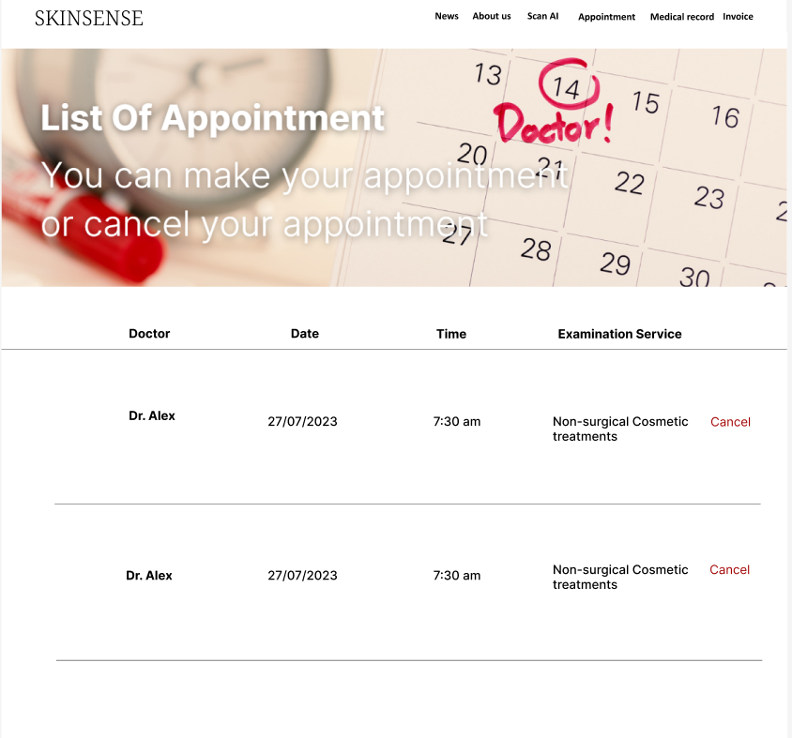

Figure 38. List of appointment in appointment page

Figure 39. Empty appointment in appointment page
- News
- Triggering a function: user enters the website path https://clinicskinsense.com and click into “News” button.
- Description of the function: display all information of news page.
- Details of the function:
  - Normal execution case:
    - User can view all information of news (figure 39).
  - Abnormal excution case:
    - Loss of connection.
- Layout of the screen:



Figure 40. News page

- Doctor home
- Triggering a function: user enters the website path https://clinicskinsense.com . Then user login as role as doctor.
- Description of the function: display appointment list, invoice, the patient examined button.
- Details of the function:
  - Normal execution case:
    - User can view all information of appointment (figure 39).
  - Abnormal excution case:
    - Loss of connection.
- Layout of the screen:
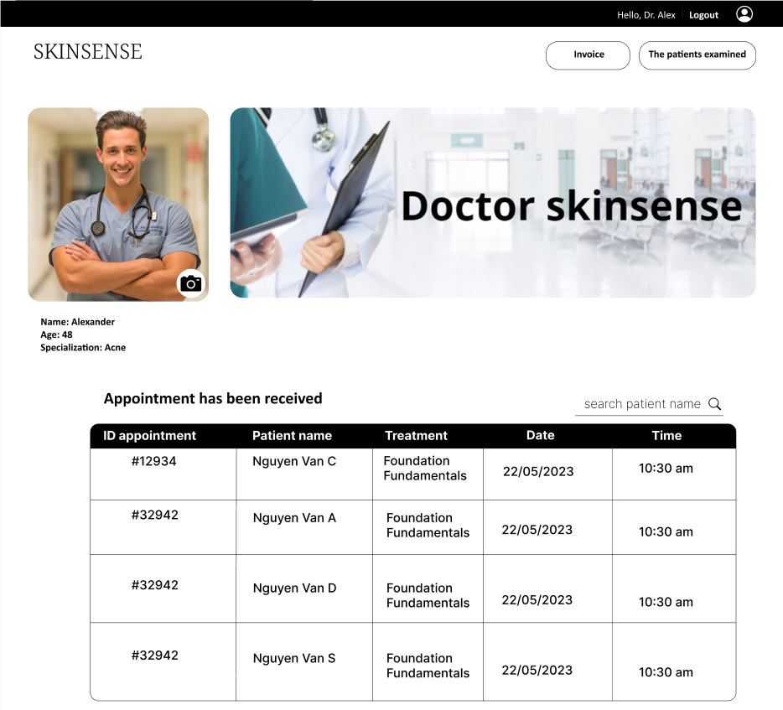

Figure 41. The patient examined page
- The Patient Examined
- Triggering a function: user enters the website path https://clinicskinsense.com . Then user login as role as doctor.
- Description of the function: displays a list of patients who have been treated and can view their medical records.
- Details of the function:
  - Normal execution case:
    - When access to the patient examined page it will displays a list of patients who have been treated (figure 42).
    - Can view the medical record of each patient (figure 43).
  - Abnormal excution case:
    - Loss of connection.
- Layout of the screen:

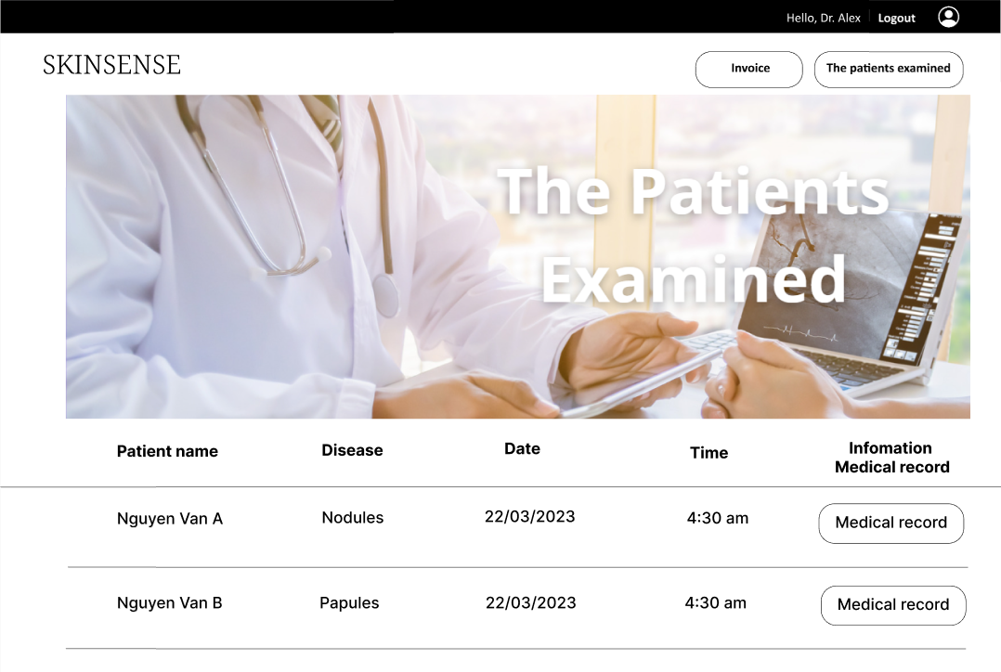

Figure 42. The patient examined page
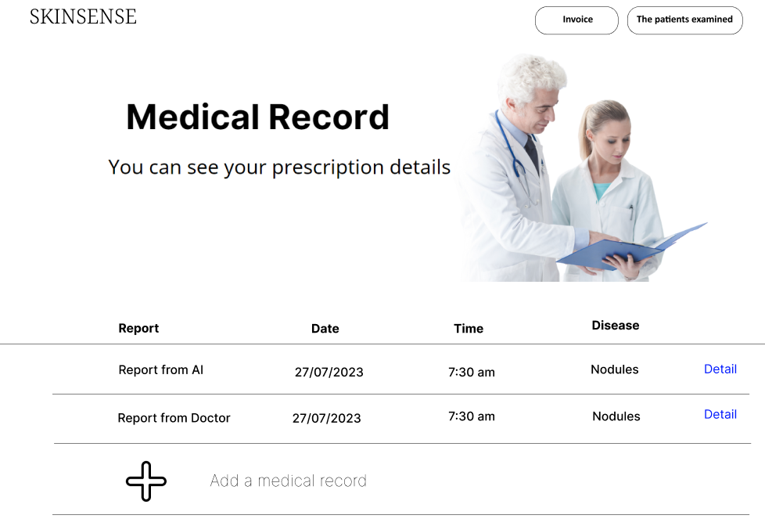
Figure 43. Medical record of patient examined
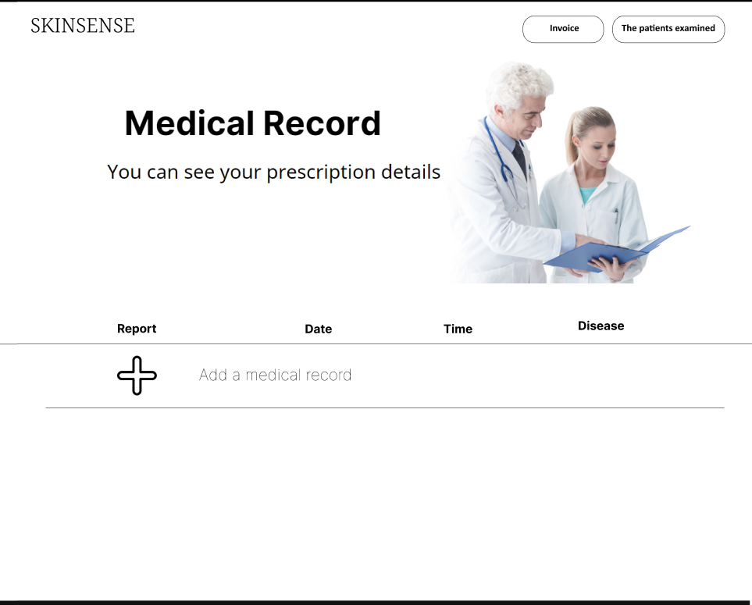
Figure 44. Empty medical record in the patient examined page
- Admin Home
- Triggering a function: user enters the website path https://clinicskinsense.com . Then user login as role as admin.
- Description of the function: Display all of functions admin, view patient, management employee, management treatment, management medicine, management room.
- Details of the function:
  - Normal execution case:
    - When access to admin home page it will displays all function of management.
  - Abnormal excution case:
    - Loss of connection.
- Layout of the screen:
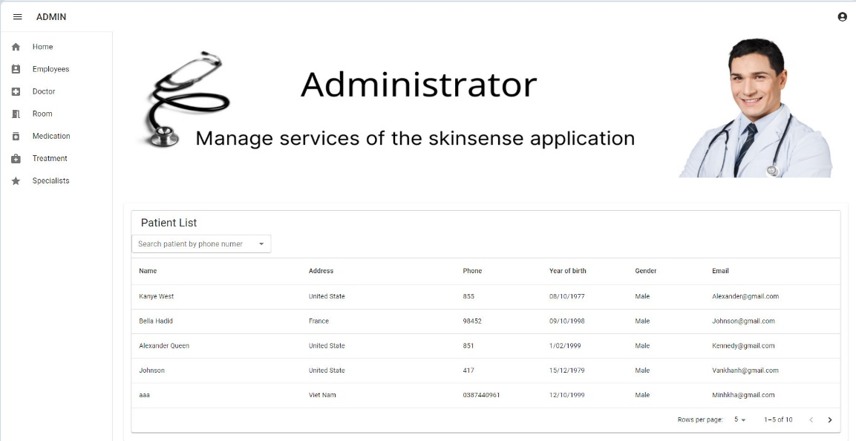
Figure 45. Admin home page
- View Patient
- Triggering a function: user enters the website path https://clinicskinsense.com . Then user login as role as admin.
- Description of the function: display a list of patients.
- Details of the function:
  - Normal execution case:
    - When access to employee page it will displays a list of patients
  - Abnormal excution case:
    - Loss of connection.
- Layout of the screen:
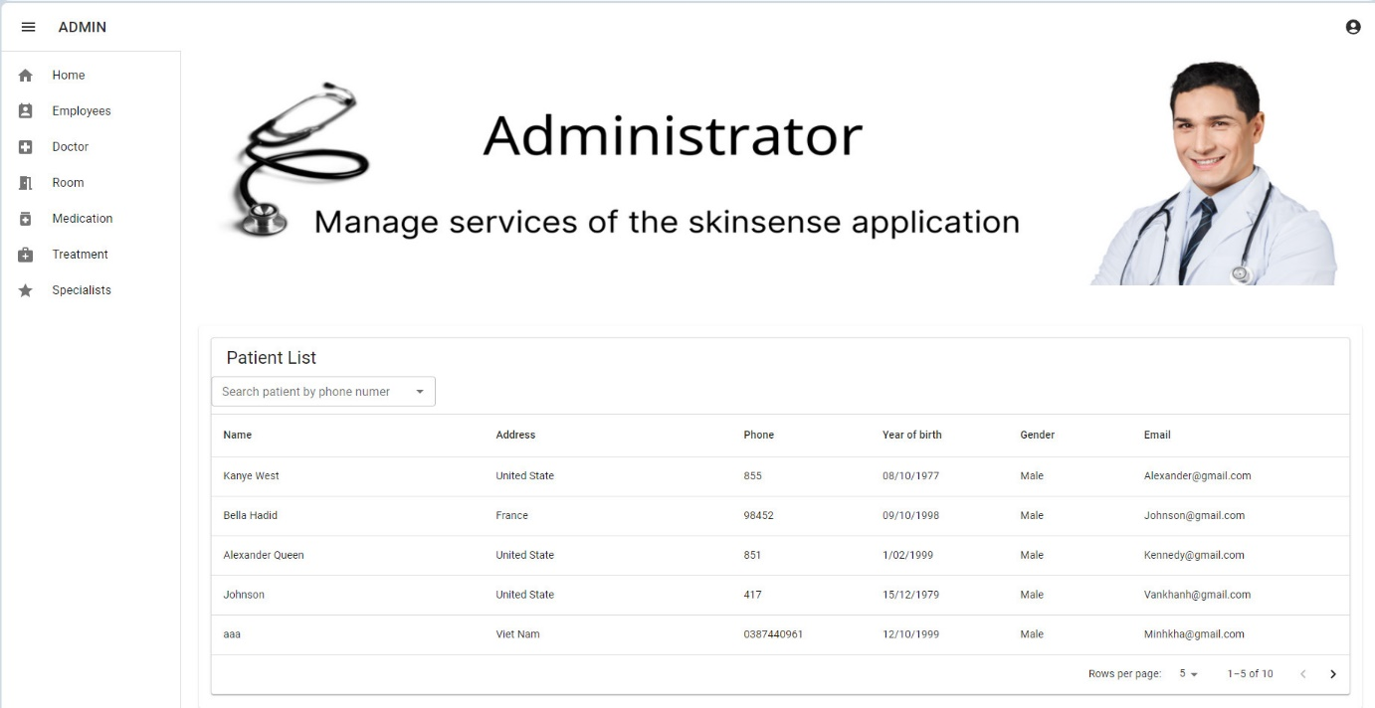
Figure 46. View patient page
- Medicine Management
- Triggering a function: user enters the website path https://clinicskinsense.com . Then user login as role as admin.
- Description of the function: display a list of medicine, creates an medicine, edits an medicine, details an medicine, and deletes an medicine.
- Details of the function:
  - Normal execution case:
    - When access to medicine page it will displays a list of medicines, create, edits, details, delete button (figure 47).
    - When creating a new medicine, a pop-up will appear and the admin will enter the necessary data to create a new one (figure 48).
    - When editing medicine information, user will be able to update all medicine related information (figure 49).
    - When viewing the details of a medicine, a pop-up will appear to display all the necessary information (figure 50).
    - When deleting a medicine, a pop-up will appear to warn if the user is sure he wants to delete or not (figure 51).
  - Abnormal excution case:
    - When the user uses the function to add a medicine but the user enters an empty field, an error message will be displayed (figure 52).
    - When the user uses the function to add a medicine, but the user enters the wrong format, an error message will be displayed (figure 53).
    - When the user uses the edit medicine function, but the user enters the wrong format and does not enter all the information, the "save change" button will not be saved (figure 54).
    - Loss of connection.
- Layout of the screen:
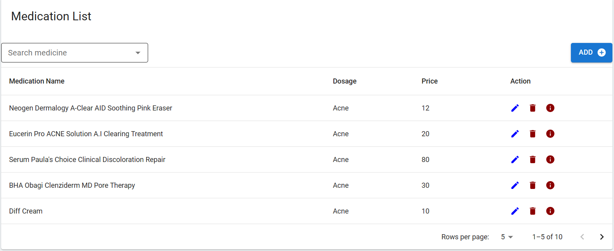
Figure 47. List of medicine page
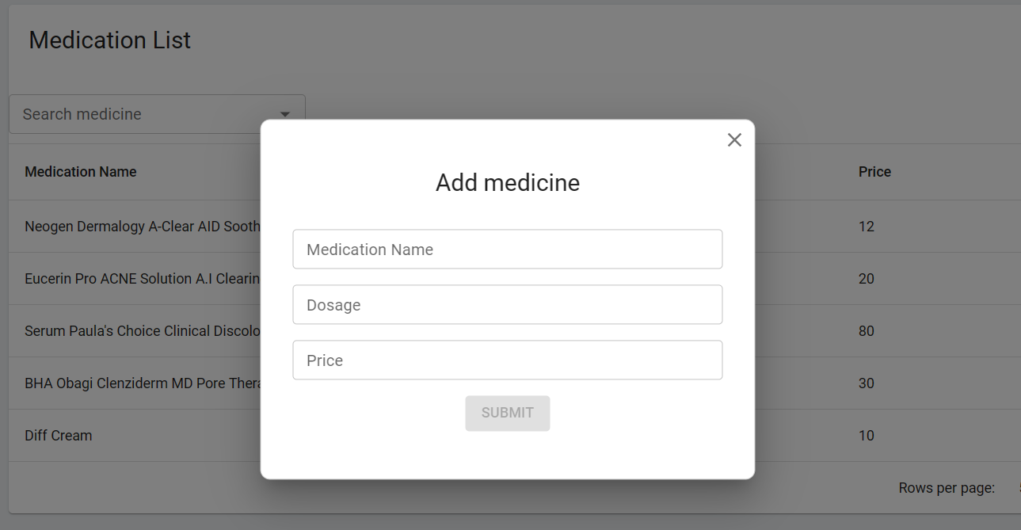
Figure 48. Create medication pop-up
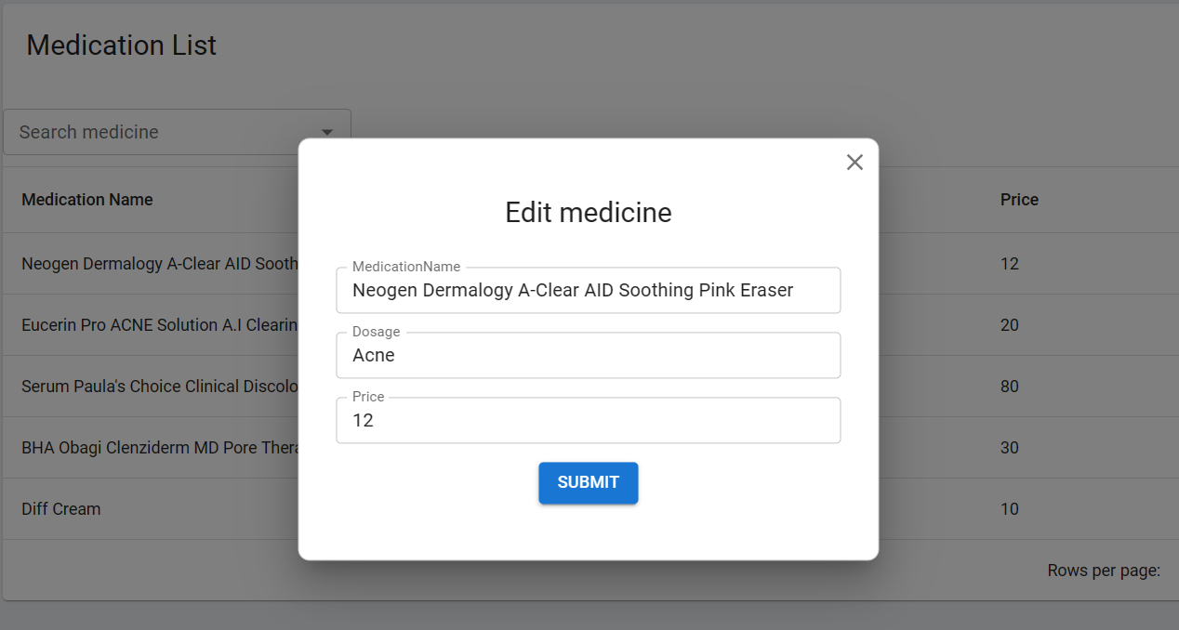
Figure 49. Edit medication pop-up
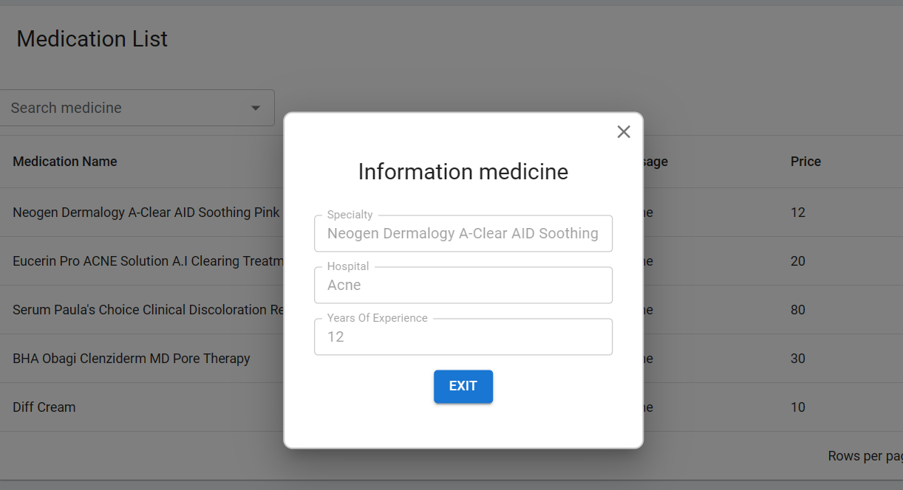
Figure 50. Details medication pop-up
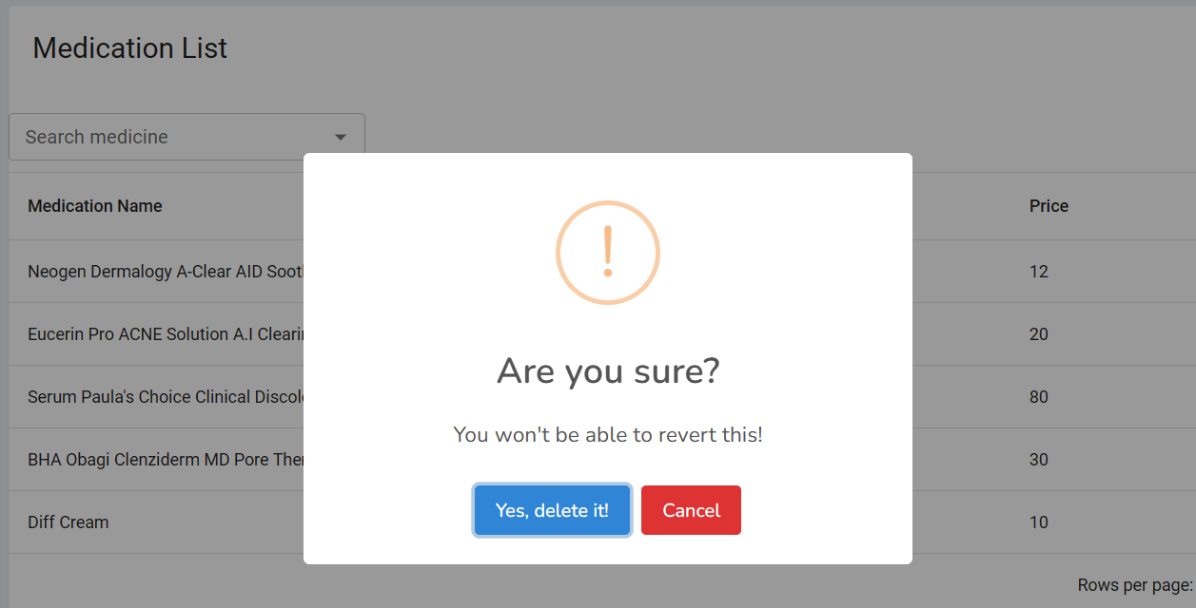
Figure 51. Delete medication pop-up
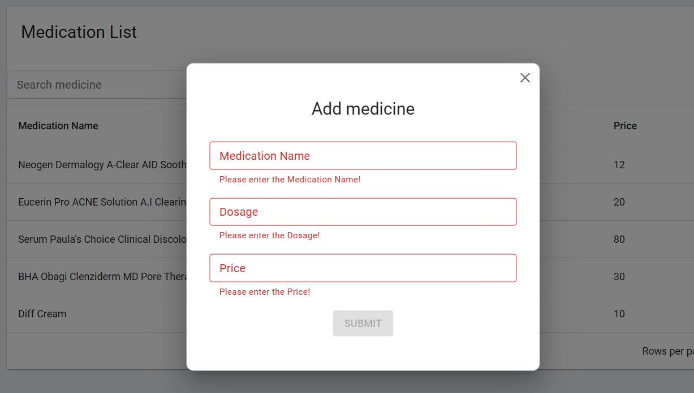
Figure 52. Validate empty in create medicine pop-up

Figure 53. Validate format in create medicine pop-up
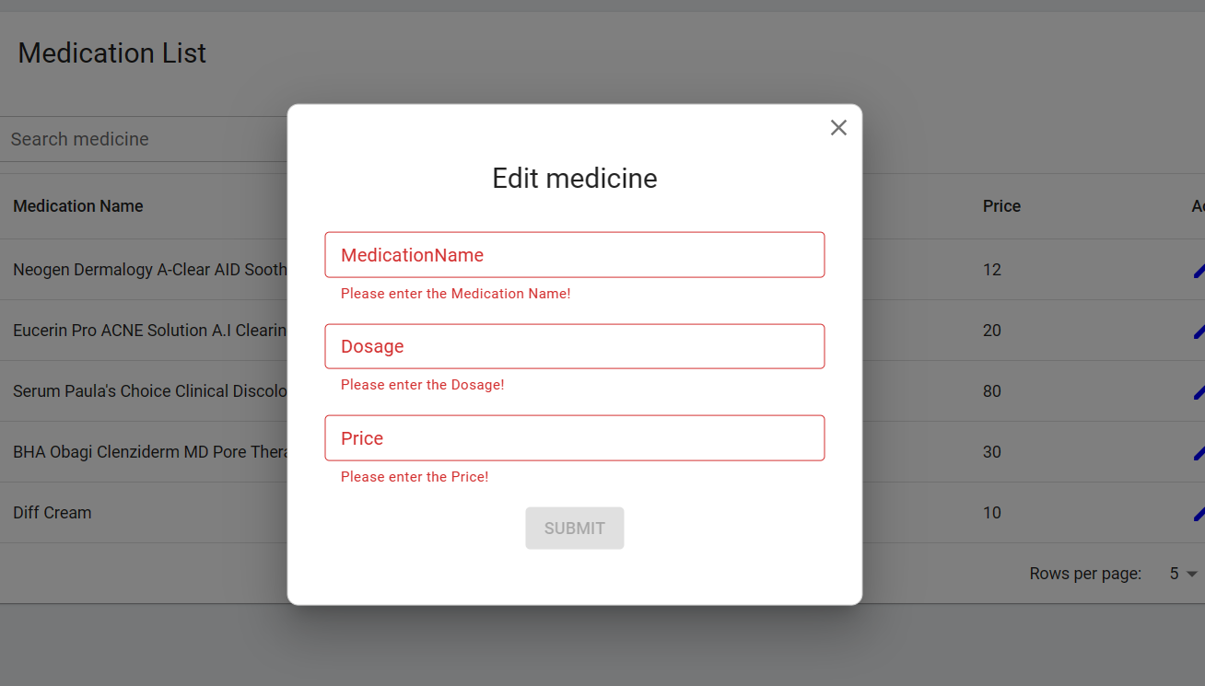
Figure 54. Validate empty in edit medication pop-up
- Room Management
- Triggering a function: user enters the website path https://clinicskinsense.com . Then user login as role as admin.
- Description of the function: display a list of room, creates a room, edits a room, details a room, and deletes a room.
- Details of the function:
  - Normal execution case:
    - When access to room page it will displays a list of rooms, create, edits, details, delete button (figure 55).
    - When creating a new room, a pop-up will appear and the admin will enter the necessary data to create a new one (figure 56).
    - When editing room information, user will be able to update all medicine related information (figure 57).
    - When viewing the details of a room, a pop-up will appear to display all the necessary information (figure 58).
    - When deleting a room, a pop-up will appear to warn if the user is sure he wants to delete or not (figure 59).
  - Abnormal excution case:
    - When the user uses the function to add a room but the user enters an empty field, an error message will be displayed (figure 61).
    - When the user uses the function to add a room, but the user enters the duplicate id, an error message will be displayed (figure 60).
    - When the user uses the edit room function, but the user enters the wrong format and does not enter all the information, the "save change" button will not be saved (figure 62).
    - Loss of connection.
- Layout of the screen:

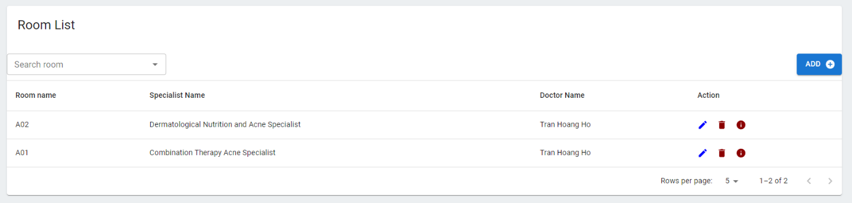
Figure 55. Room page
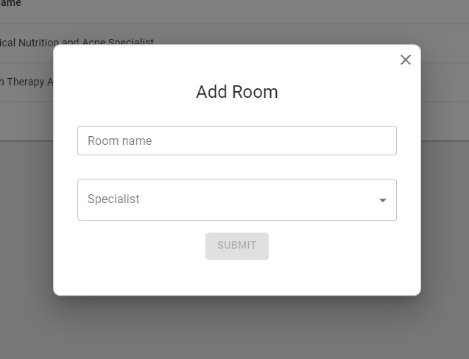
Figure 56. Create room
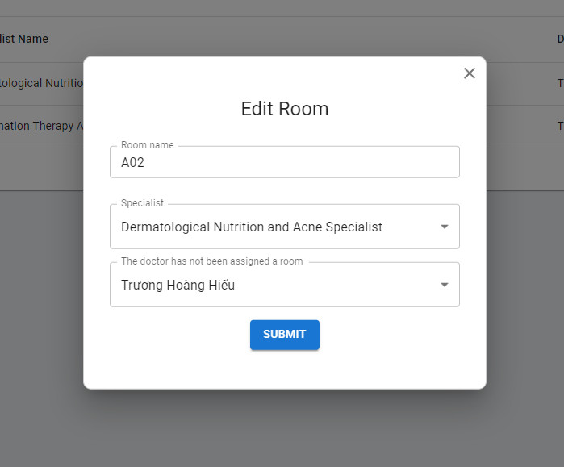
Figure 57. Edit room page
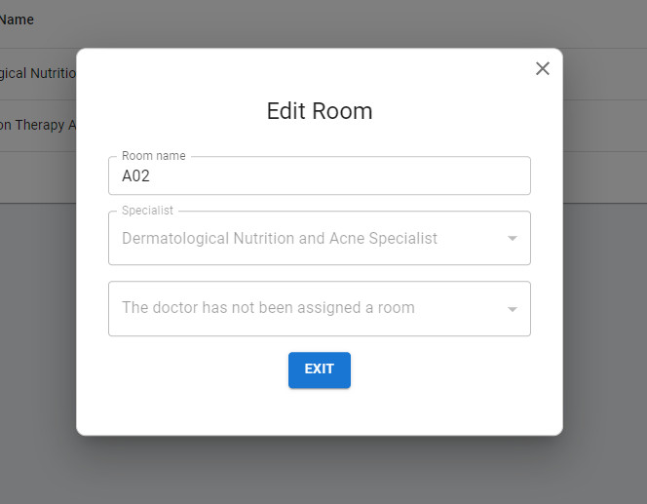
Figure 58. Details room page
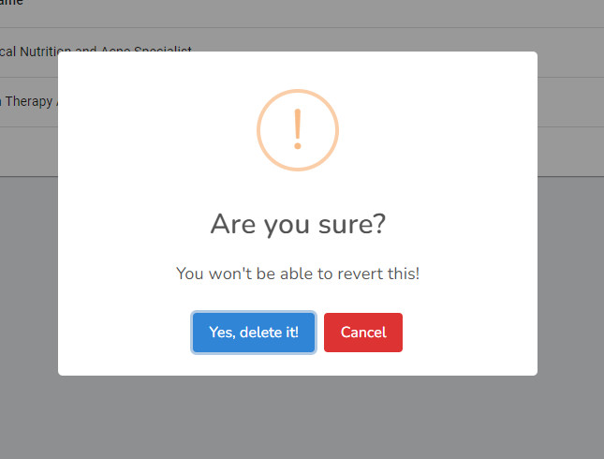
Figure 59. Delete room page
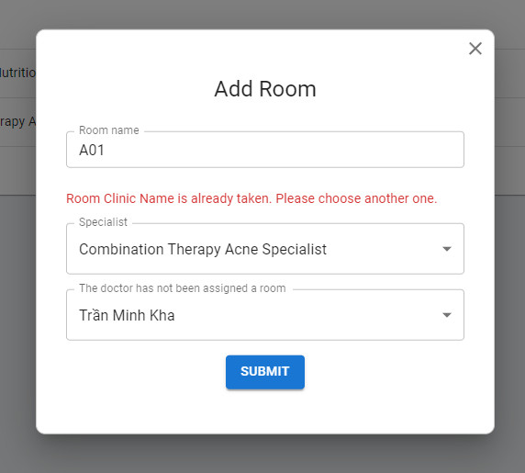
Figure 60. Duplicate room id validation in create room page
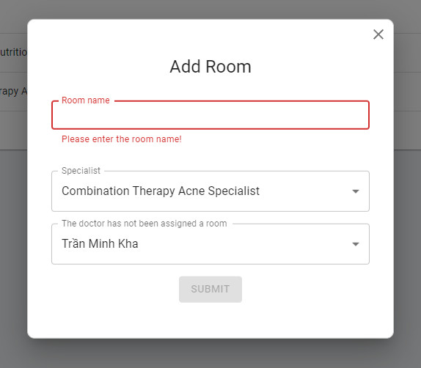
Figure 61. Empty validation in create room page
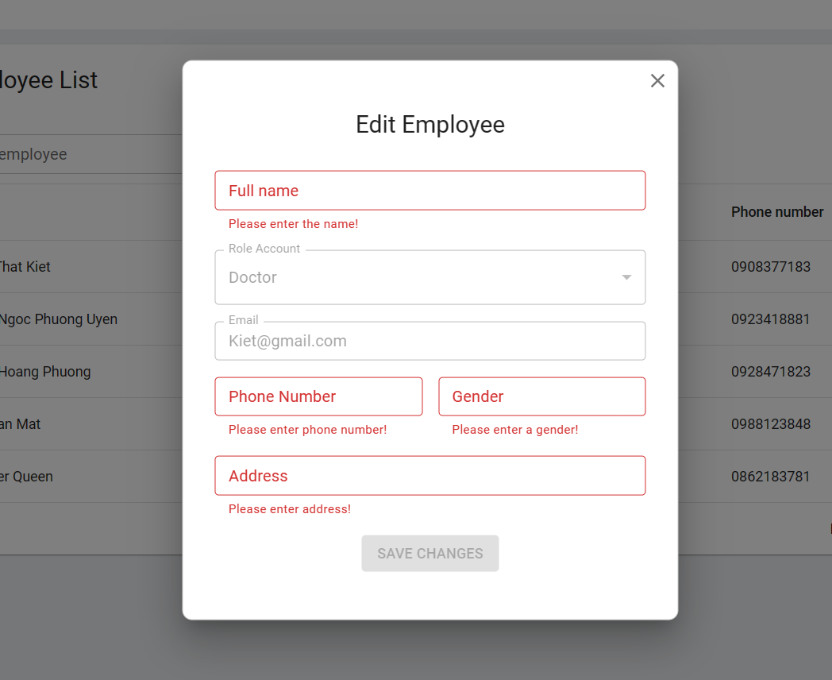
Figure 62. Empty validation in edit room page
- Treatment Management
- Triggering a function: user enters the website path https://clinicskinsense.com . Then user login as role as admin.
- Description of the function: display a list of treatment, creates a treatment, edits a treatment, details a treatment, and deletes a treatment.
- Details of the function:
  - Normal execution case:
    - When access to treatment page it will displays a list of treatments, create, edits, details, delete button (figure 63).
    - When creating a new treatment, a pop-up will appear and the admin will enter the necessary data to create a new one (figure 64).
    - When editing treatment information, user will be able to update all treatment related information (figure 65).
    - When viewing the details of a treatment, a pop-up will appear to display all the necessary information (figure 66).
    - When deleting a treatment, a pop-up will appear to warn if the user is sure he wants to delete or not (figure 67).
  - Abnormal excution case:
    - When the user uses the function to add a treatment but the user enters an empty field, an error message will be displayed (figure 68).
    - When the user uses the function to add a treatment, but the user enters the wrong format, an error message will be displayed (figure 69).
    - When the user uses the edit treatment function, but the user enters the wrong format and does not enter all the information, the "save change" button will not be saved (figure 70).
    - Loss of connection.
- Layout of the screen:
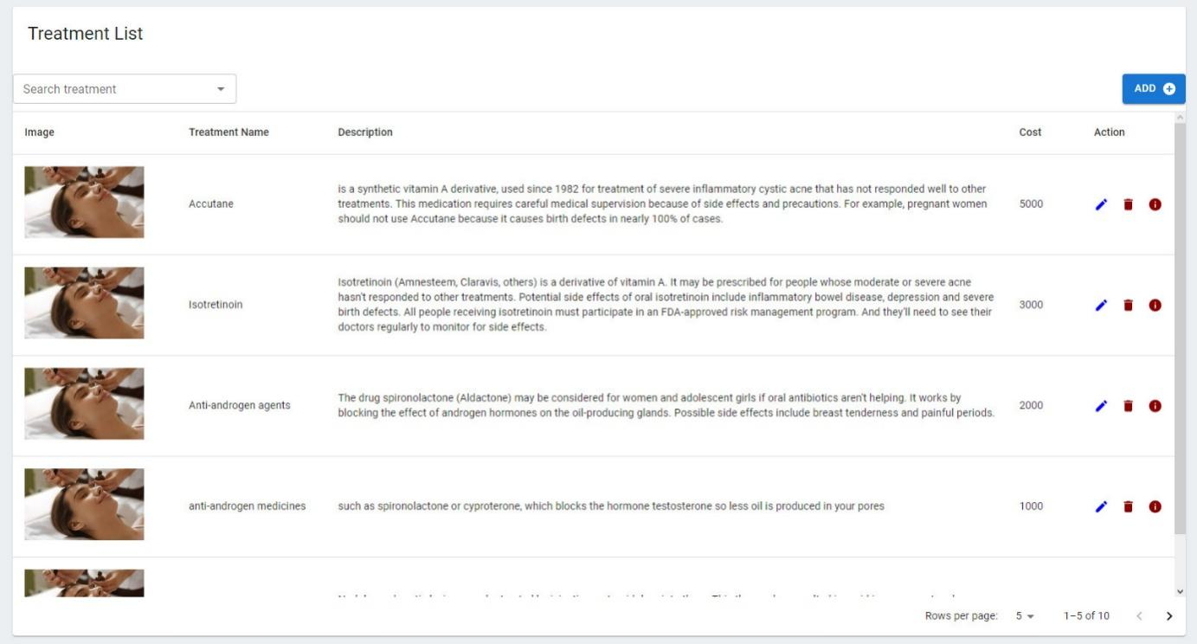
Figure 63. Treatment list page
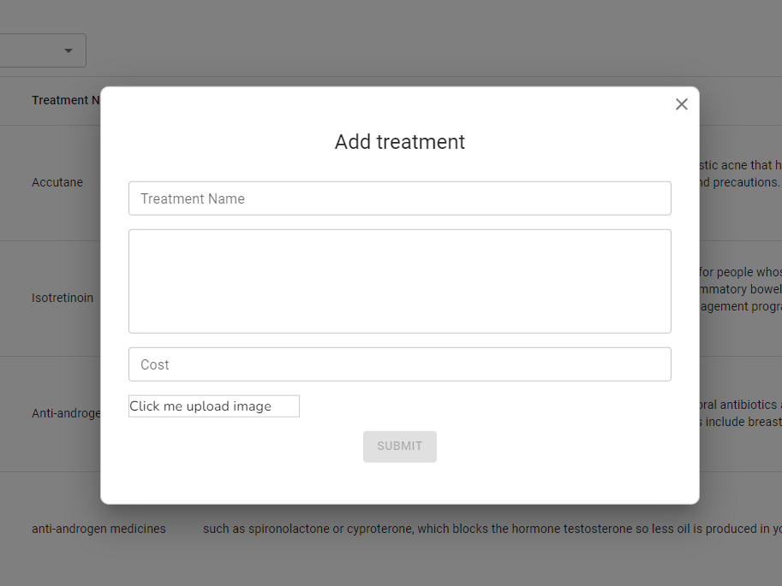
Figure 64. Create treatment page
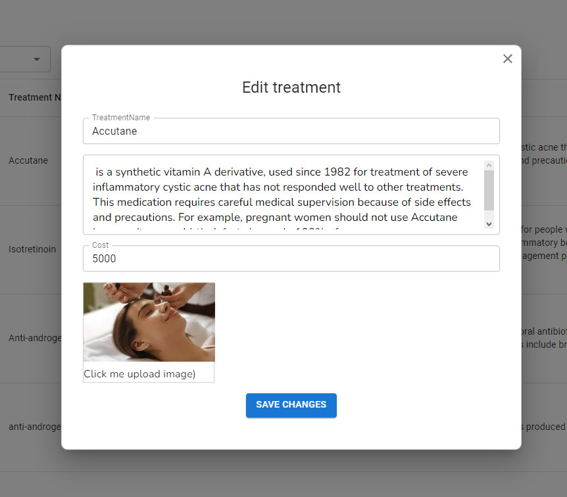
Figure 65. Edit treatment page
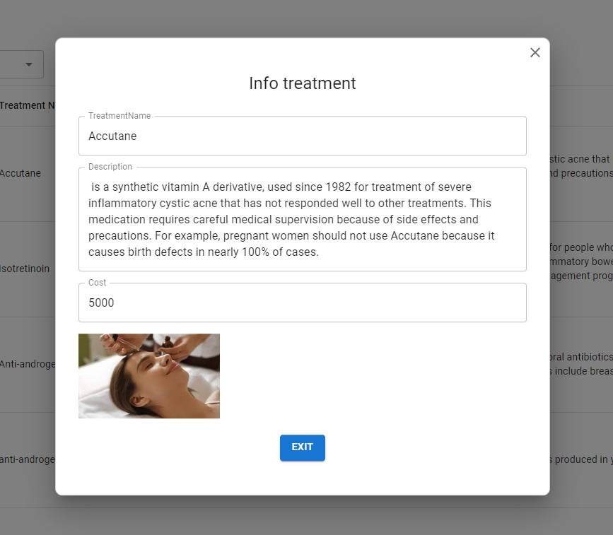
Figure 66. Details treatment page
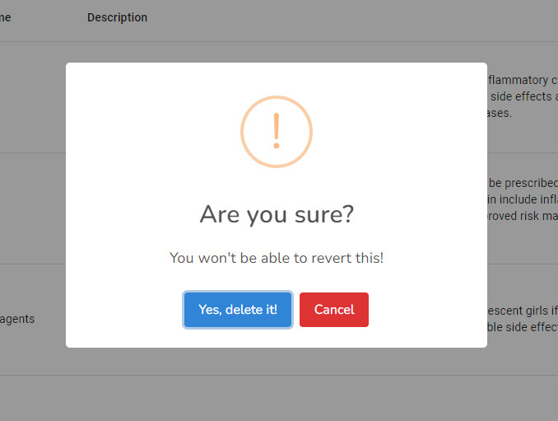
Figure 67. Delete treatment page
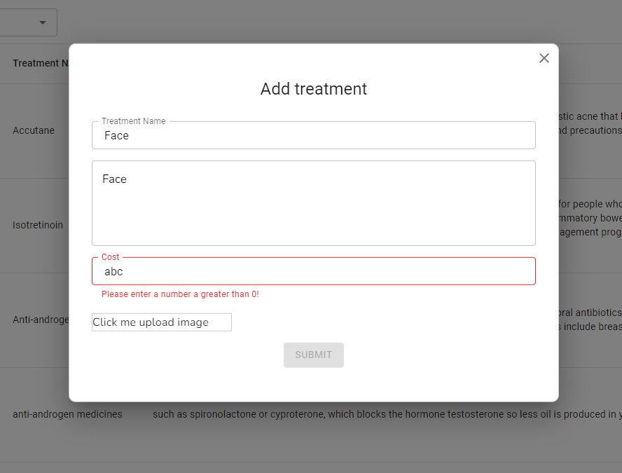
Figure 68. Empty validation in create treatment page
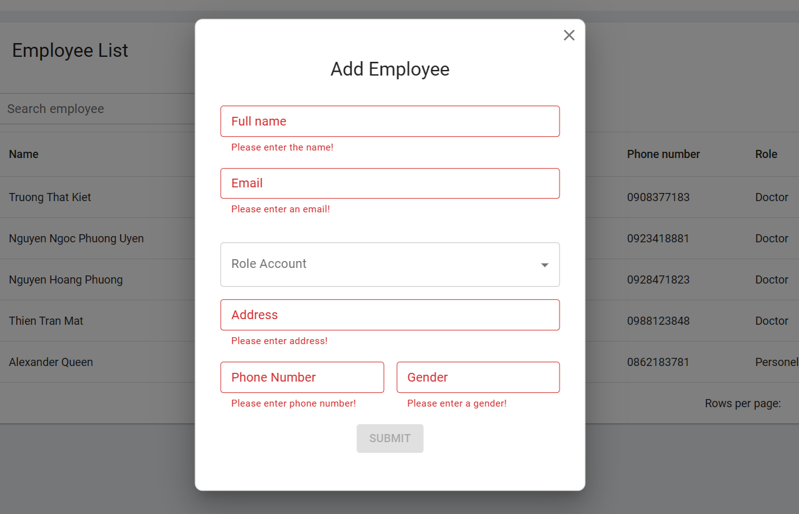
Figure 69. Format validation in create treatment page

Figure 70. Empty validation in treatment page
- Employee Management
- Triggering a function: user enters the website path https://clinicskinsense.com . Then user login as role as admin.
- Description of the function: display a list of employees, creates an employee, edits an employee, details an employee, and deletes an employee.
- Details of the function:
  - Normal execution case:
    - When access to employee page it will displays a list of employees, create, edits, details, delete button (figure 71).
    - When creating a new employee, a pop-up will appear and the admin will enter the necessary data to create a new one (figure 72).
    - When editing employee information, user will be able to update all employee related information (figure 73).
    - When viewing the details of an employee, a pop-up will appear to display all the necessary information (figure 74).
    - When deleting an employee, a pop-up will appear to warn if the user is sure he wants to delete or not (figure 75).
  - Abnormal excution case:
    - When the user uses the function to add an employee but the user enters an empty field, an error message will be displayed (figure 76).
    - When the user uses the function to add an employee, but the user enters the wrong format, an error message will be displayed (figure 77).
    - When the user uses the edit employee function, but the user enters the wrong format and does not enter all the information, the "save change" button will not be saved (figure 78).
    - Loss of connection.
- Layout of the screen:

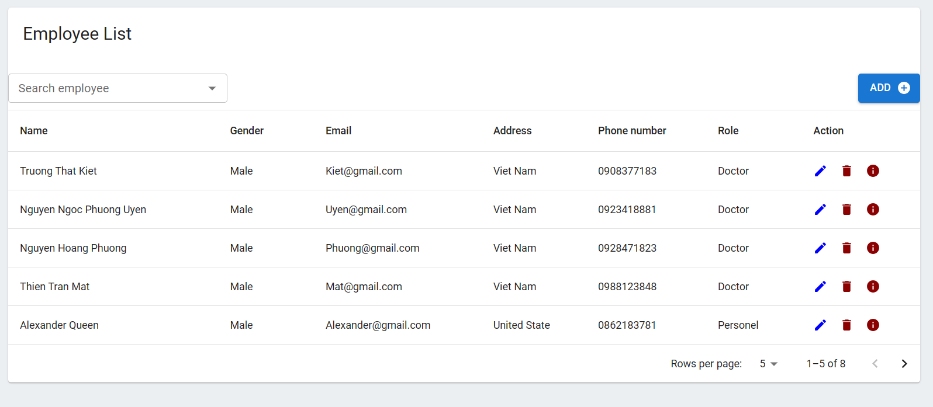

Figure 71. Employee page
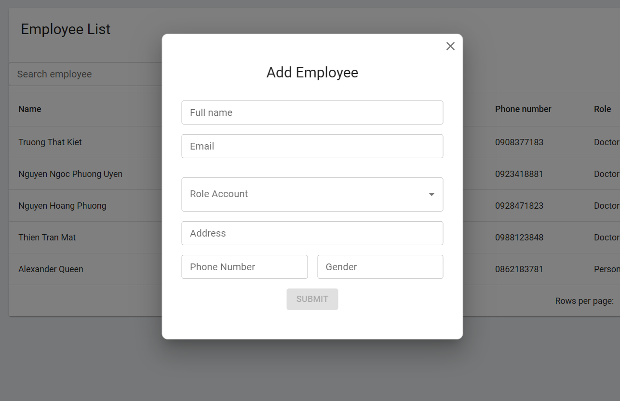
Figure 72. Create employee pop-up
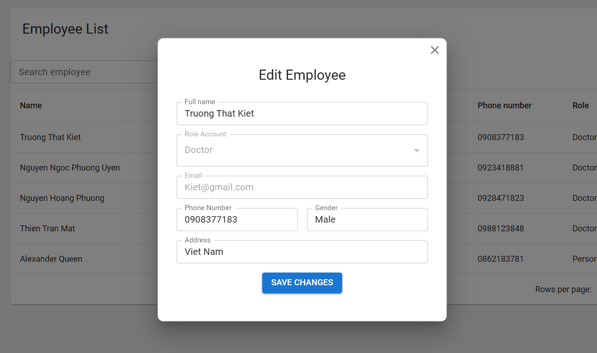
Figure 73. Edit employee pop-up
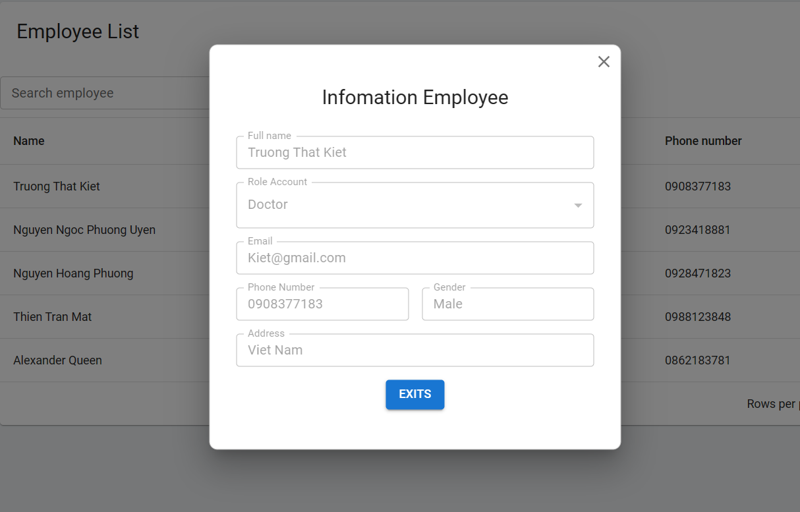
Figure 74. Details employee pop-up
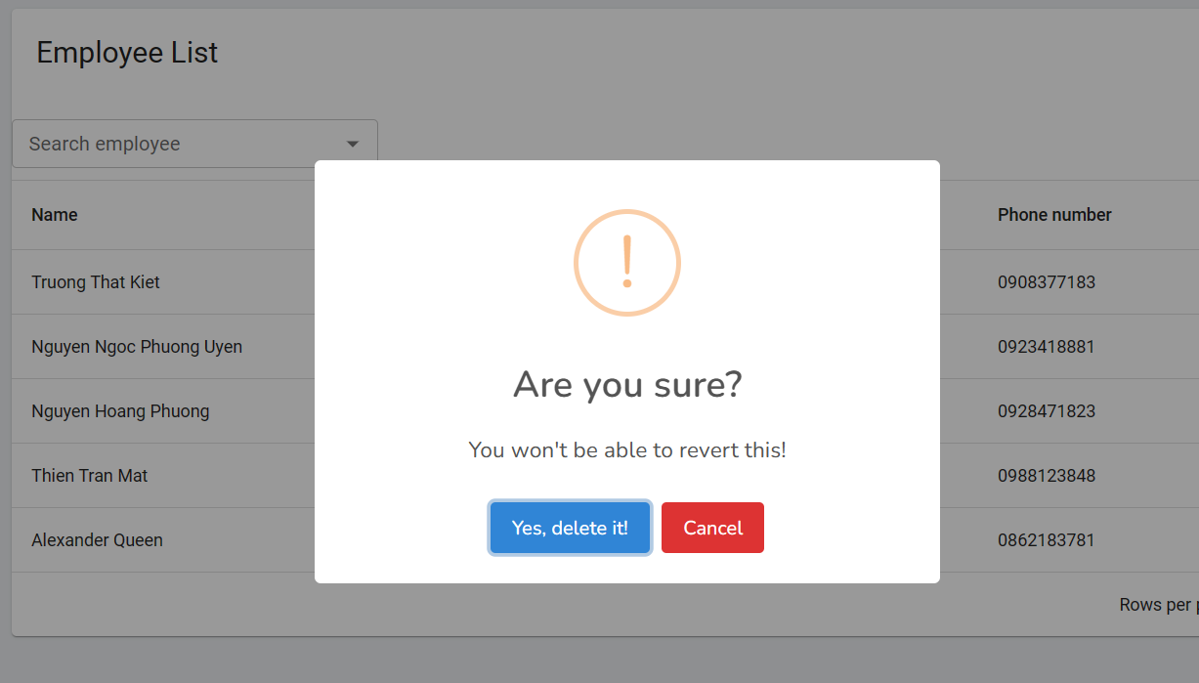
Figure 75. Delete employee pop-up
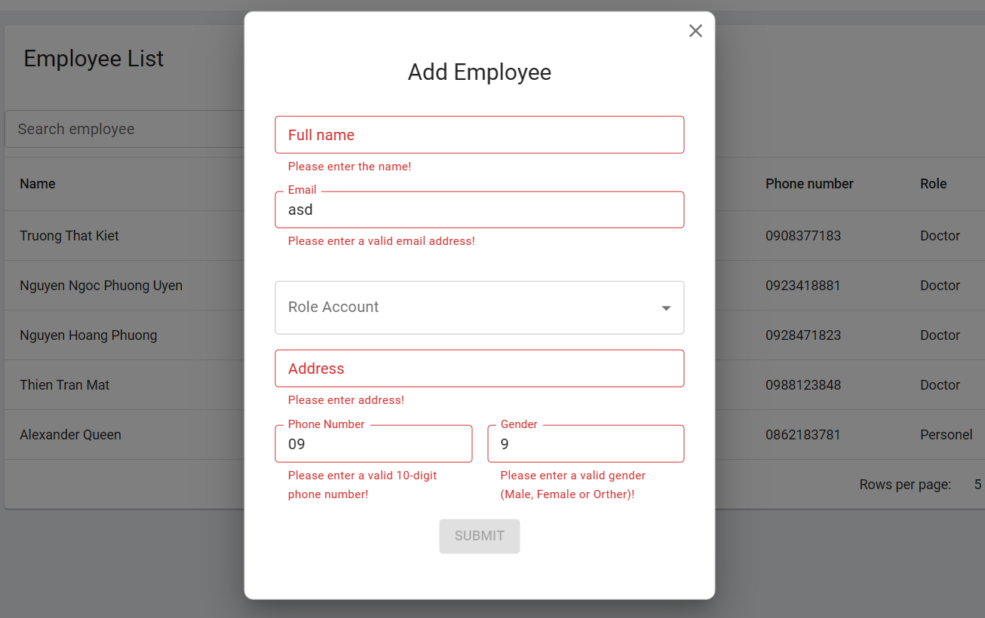
Figure 76. Validate format in create employee pop-up

Figure 77. Empty employee in employee pop-up

Figure 78. Empty employee in employee pop-up
- Staff Home
- News Management
- Appointment Management
- Invoice Management

3.3.3 Skinsense in android application
- Login
- Triggering a function: the user will open the Skinsense app and be redirected to the Skinsense welcome page. The user will press the "Login" button to go to the login screen.
- Description of the function: security of user information.
- Details of the function:
  - Normal execution case:
    - Screen shows login button, register button (figure 78).
    - The screen will display 2 input fields "email" and "password". In addition, there will be an "forget password" button (figure 79).
  - Abnormal excution case:
    - Loss of connection.
- Layout of the screen:
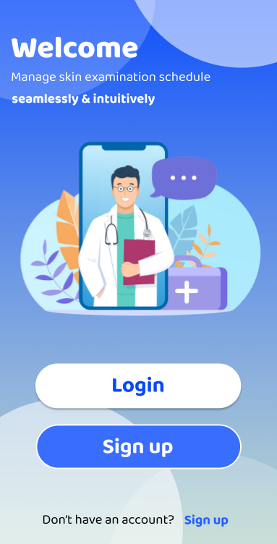
Figure 79. Welcome skinsense screen
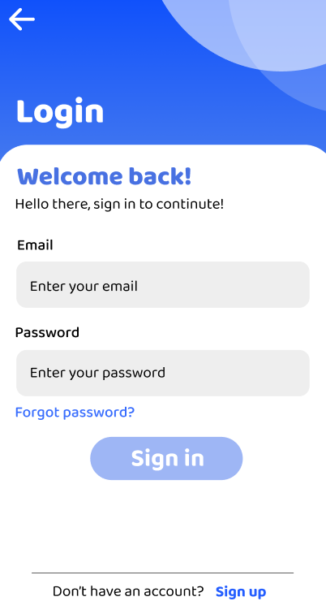

Figure 80. Login screen
- Logout
- Triggering a function: the user will open the Skinsense app and be redirected to the Skinsense welcome page. The user will press the "Profile" button to go to the Profile screen.
- Description of the function: log out of application.
- Details of the function:
  - Normal execution case:
    - The screen shows the profile user and all of the functions in the application, and the “logout” button (figure 80).
  - Abnormal excution case:
    - Loss of connection.
- Layout of the screen:

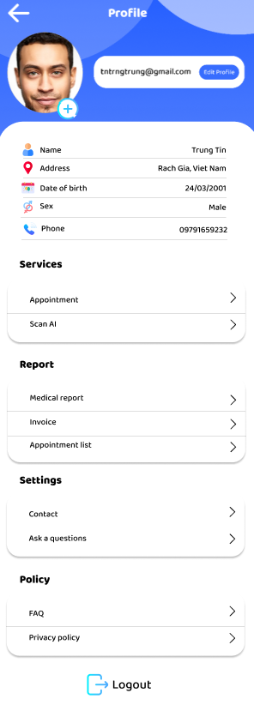

Figure 81. Log out in profile screen
- Forget Password
- Triggering a function: the user will open the Skinsense app and be redirected to the Skinsense welcome page. The user will select the login button to enter the "login" page and press the "Forget Password" button to go to the forget password screen.
- Description of the function: Secure the user's password information.
- Details of the function:
  - Normal execution case:
    - The user enters an email in the input field to be able to send the verification code used to authenticate the email (figure 81).
    - The user will enter the 4-digit code that was sent in the email to confirm their email (figure 82).
    - After successfully confirming the email, the user will be able to enter a new password and re-enter the password again to confirm the match.
  - Abnormal excution case:
    - Loss of connection.
- Layout of the screen:

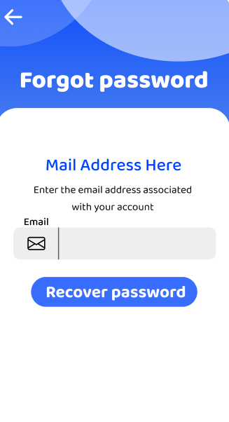
Figure 82. Forgot password screen step 1
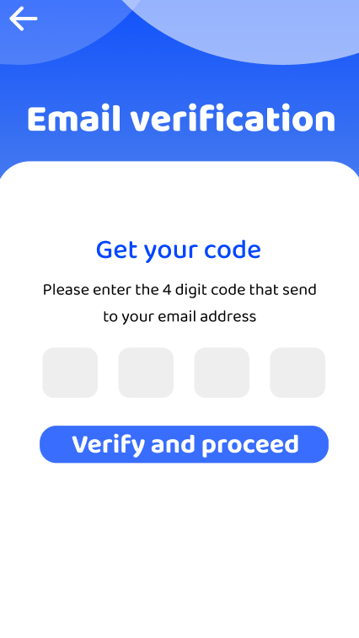
Figure 83. Forgot password screen step 2
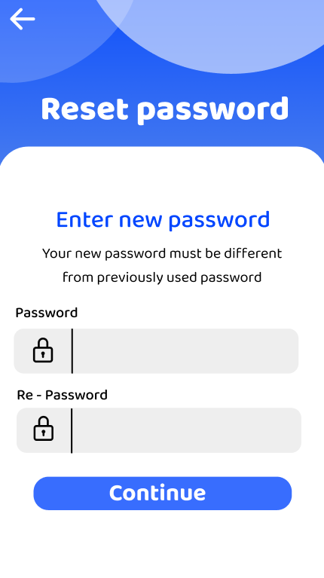
Figure 84. Forgot password screen step 3
- Register
- Triggering a function: the user will open the Skinsense app and be redirected to the Skinsense welcome page. The user will select the register button to enter the "register" page.
- Description of the function: create a new user's account.
- Details of the function:
  - Normal execution case:
    - Users will be able to enter information related to themselves and email and password to be able to log into the system (figure 85).
    - When pressing the "register" button, the user will receive an email from the server side to send a code to enter to confirm the official email (figure 86).
  - Abnormal excution case:
    - Check the validation format of each input field in the register page (figure 87).
    - Loss of connection.
- Layout of the screen:
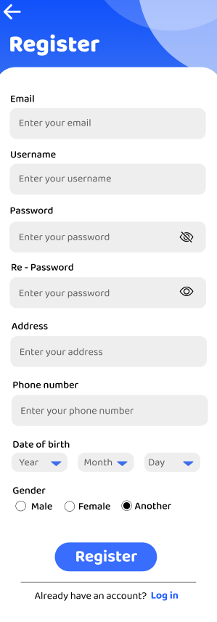

Figure 85. Register screen
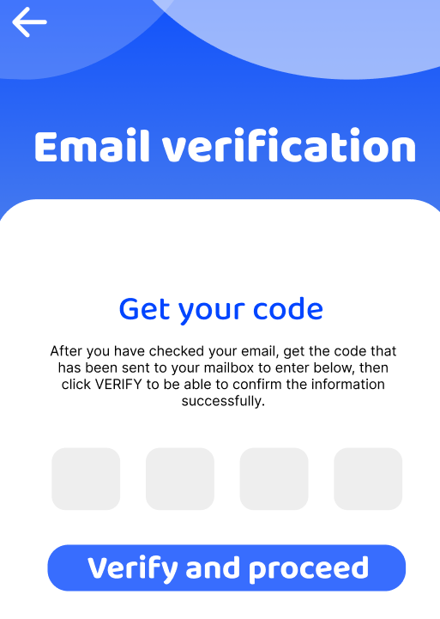

Figure 86. Email verification in register screen
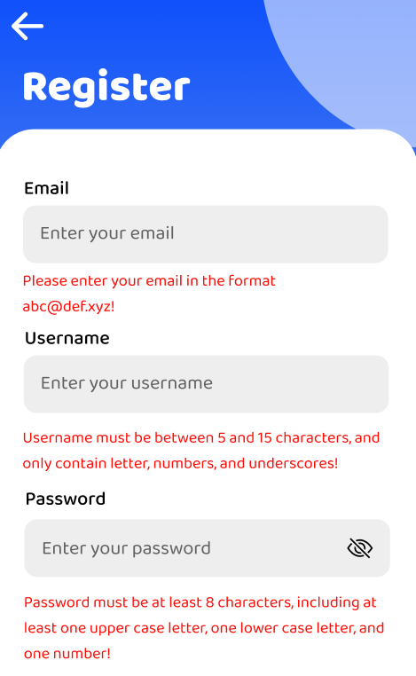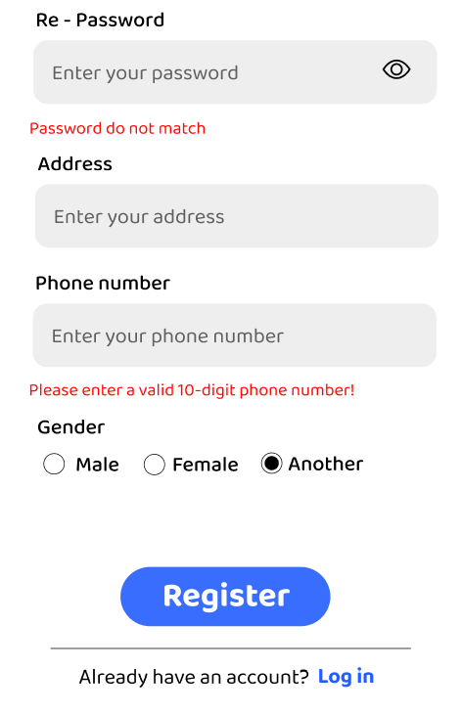
Figure 87. Validation format in register screen
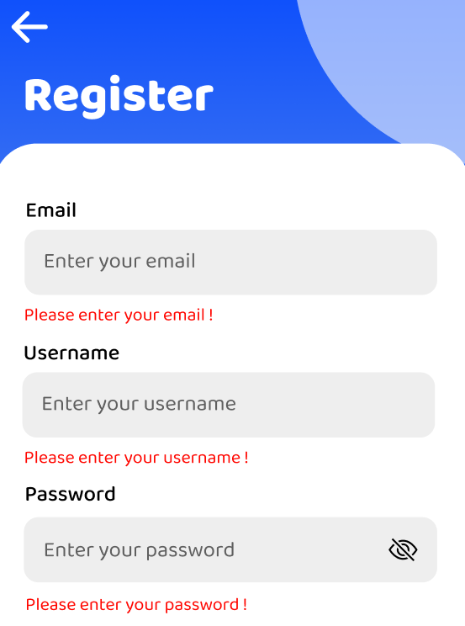
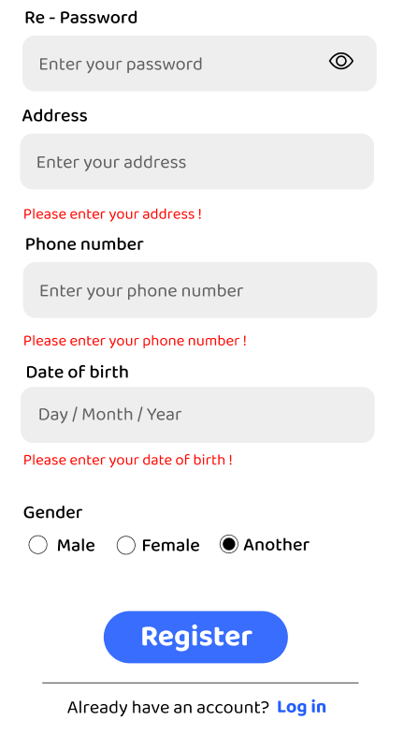
Figure 88. Validation is empty in the register screen.
- Patient Home Menu
- Triggering a function: the user will open the Skinsense app and be redirected to the Skinsense welcome page. The user will login as a patient.
- Description of the function: make it easy for users to access the system's functions.
- Details of the function:
  - Normal execution case:
    - Display menu screen and system functions (figure 89).
  - Abnormal excution case:
    - Loss of connection.
- Layout of the screen:
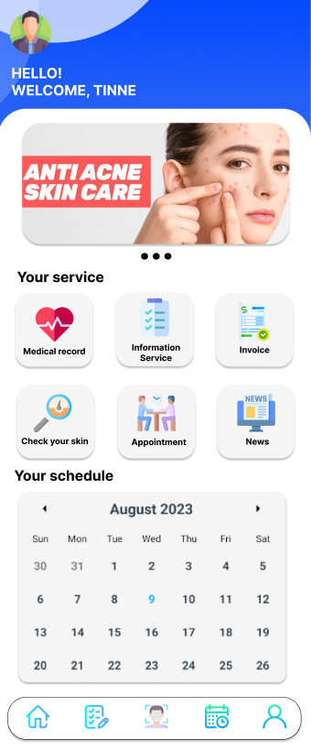
Figure 89. Patient Home Screen
- Profile
- Triggering a function: user will open the Skinsense app and be redirected to the Skinsense welcome page. The user will login as a patient and then select the user image to be able to enter the profile screen.
- Description of the function: Display user's information and can edit information by pressing "edit profile" button.
- Details of the function:
  - Normal execution case:
    - Display user's information and can edit information by pressing "edit profile" button (figure 90).
    - When users access the "edit profile" screen, they will be able to edit their information at will and can change their password and email (figure 91).
  - Abnormal excution case:
    - Loss of connection.
- Layout of the screen:

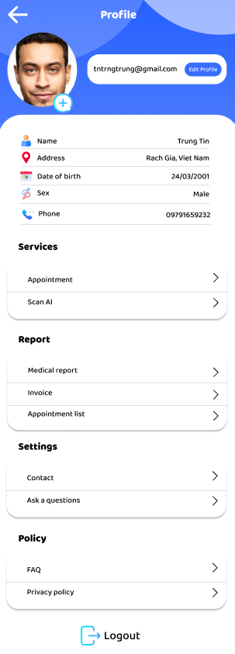
Figure 90. Profile screen
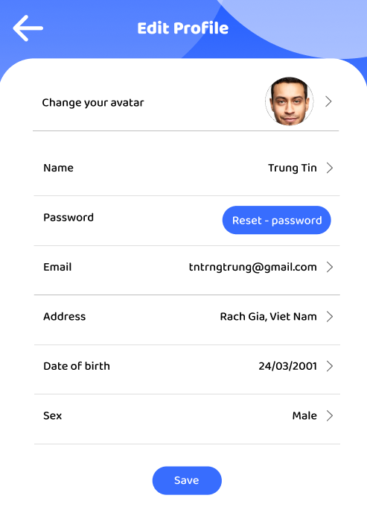

Figure 91. Edit profile screen
- Reset Password
- Triggering a function: user will open the Skinsense app and be redirected to the Skinsense welcome page. The user will login as a patient and then select the user image to be able to enter the profile screen. After access into profile screen, user click in “edit profile” button.
- Description of the function: change new password.
- Details of the function:
  - Normal execution case:
    - Display password reset screen and 3 input fields to change new password (figure 92).
  - Abnormal excution case:
    - Show error message when user enters empty (figure 9).
- Layout of the screen:

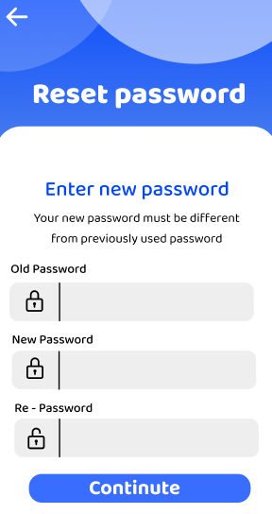

Figure 92. Reset password in profile page
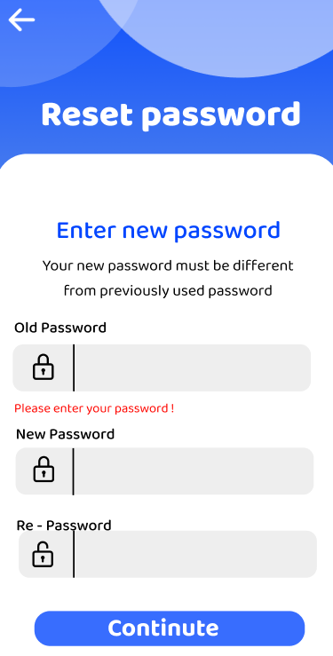
Figure 93. Validate empty in reset password screen
- Invoice
- Triggering a function: user will open the Skinsense app and be redirected to the Skinsense welcome page. The user will login as a patient and user click in “invoice” button.
- Description of the function: display list of invoices, details an invoice.
- Details of the function:
  - Normal execution case:
    - Display list of patient invoices (figure 94).
    - Display details the patient invoice (figure 95).
    - Display details in paid status (figure 96).
    - Display details in unpaid status (figure 97)
  - Abnormal excution case:
    - Show error message when empty invoices (figure 98).
- Layout of the screen:
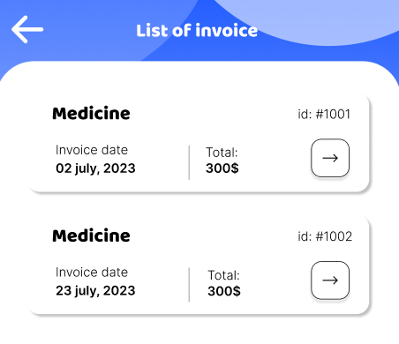
Figure 94. List of invoices screen
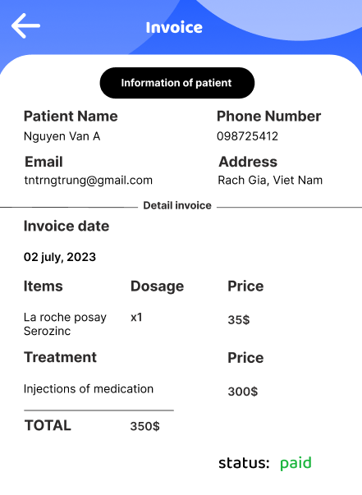

Figure 95. Invoice details in paid status screen
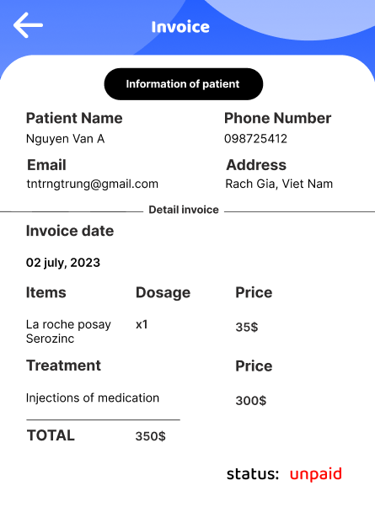

Figure 96. Invoice details in unpaid status screen
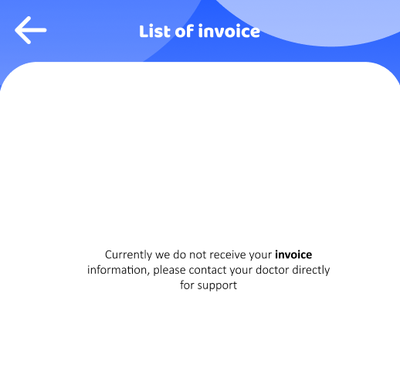
Figure 97. Empty invoice screen
- Medical Record
- Triggering a function: user will open the Skinsense app and be redirected to the Skinsense welcome page. The user will login as a patient and user click in “medical record” button.
- Description of the function: display list of medical records, details an medical record.
- Details of the function:
  - Normal execution case:
    - Display list of medical records (figure 98).
    - Display details the patient medical records (figure 99).
  - Abnormal excution case:
    - Show error message when empty invoices (figure 100 ).
- Layout of the screen:

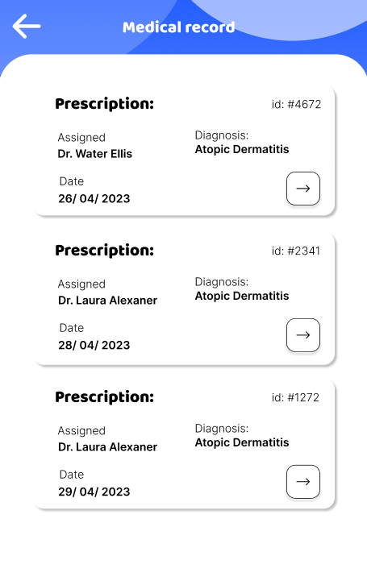
Figure 98. List of medical records screen

Figure 99. Details an invoice screen
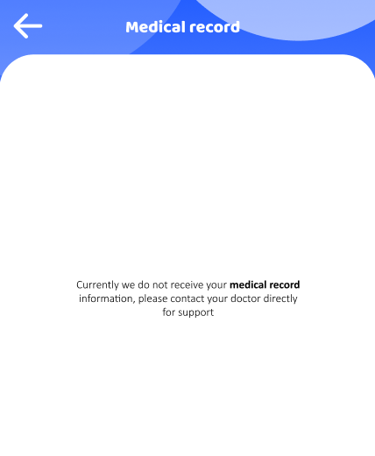
Figure 100. Empty invoice screen
- Scan AI Detection
- Triggering a function: the user will open the Skinsense app and be redirected to the Skinsense welcome page. The user will select the scan AI button to enter the "scan AI" screen.
- Description of the function: take a picture of the patient's face to detect acne through AI
- Details of the function:
  - Normal execution case:
    - Show face camera (figure 101).
  - Abnormal excution case:
    - Loss of connection.
- Layout of the screen:


Figure 101. Camera scan AI detection acne
- Test Result
- Triggering a function: the user will open the Skinsense app and be redirected to the Skinsense welcome page. Log in with patient account, User will select medical record button and will select patient record with AI results.
- Description of the function: display AI acne detection results.
- Details of the function:
  - Normal execution case:
    - Show test result AI (figure 102).
  - Abnormal excution case:
    - Loss of connection.
- Layout of the screen:

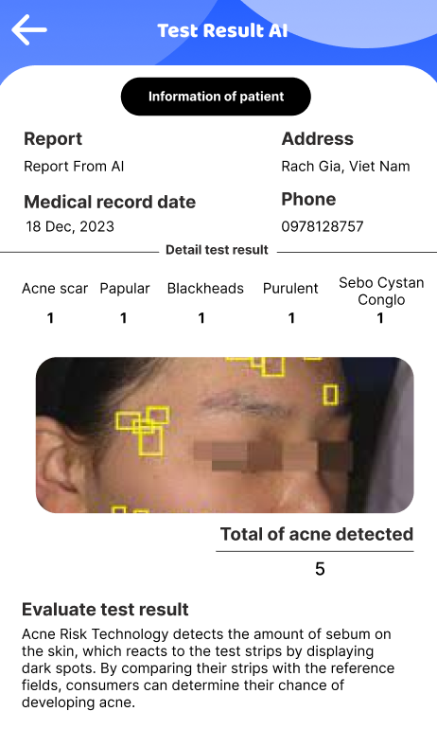
Figure 102. Test result AI screen
- News
- Triggering a function: the user will open the Skinsense app and be redirected to the Skinsense welcome page. User will select news button.
- Description of the function: display news information.
- Details of the function:
  - Normal execution case:
    - Show news (figure 103).
  - Abnormal excution case:
    - Loss of connection.
- Layout of the screen:


Figure 103. News screen

- Appointment
- Triggering a function: the user will open the Skinsense app and be redirected to the Skinsense welcome page. Log in with patient account, User will select appointment button.
- Description of the function: users will be able to book an appointment.
- Details of the function:
  - Normal execution case:
    - User will choose examination service, doctor, examination date and finally choose a settable time frame (figure 104).
  - Abnormal excution case:
    - Loss of connection.
- Layout of the screen:

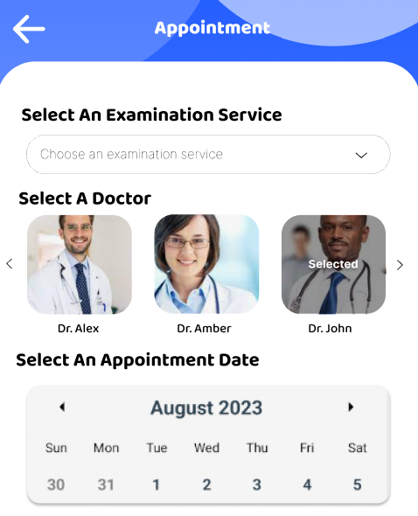
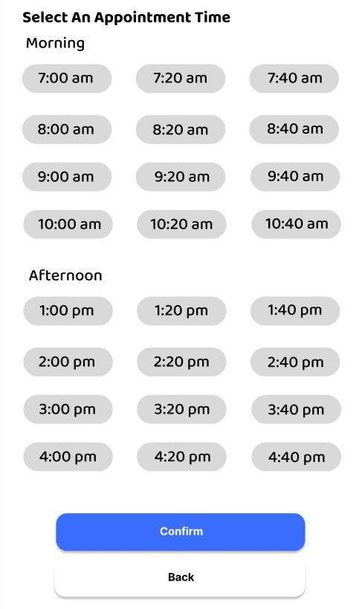
Figure 104. Appointment screen

- Doctor home
- Triggering a function: the user will open the Skinsense app and be redirected to the Skinsense welcome page. Log in with doctor account
- Description of the function: users will be able to book an appointment.
- Details of the function:
  - Normal execution case:
    - User will choose examination service, doctor, examination date and finally choose a settable time frame (figure 104).
  - Abnormal excution case:
    - Loss of connection.
- Layout of the screen:

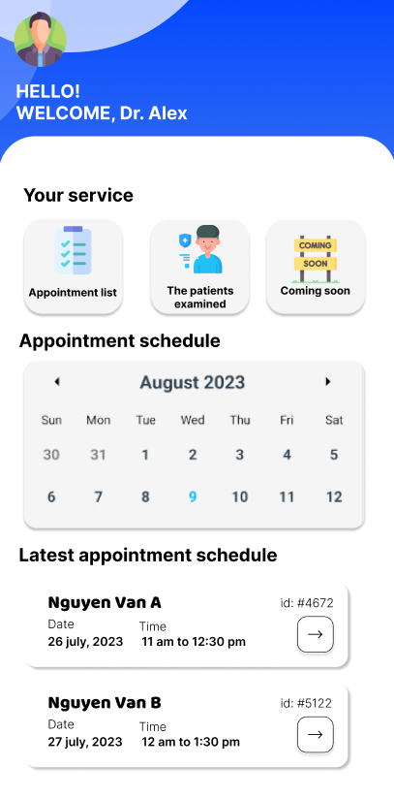
Figure 105. Doctor home screen

- The patient examined
- Triggering a function: the user will open the Skinsense app and be redirected to the Skinsense welcome page. Log in with patient account, User will select the patient examined button.
- Description of the function: doctors can see patients who have booked appointments
- Details of the function:
  - Normal execution case:
    - Show list of patient examined (figure 106).
  - Abnormal excution case:
    - Loss of connection.
- Layout of the screen:
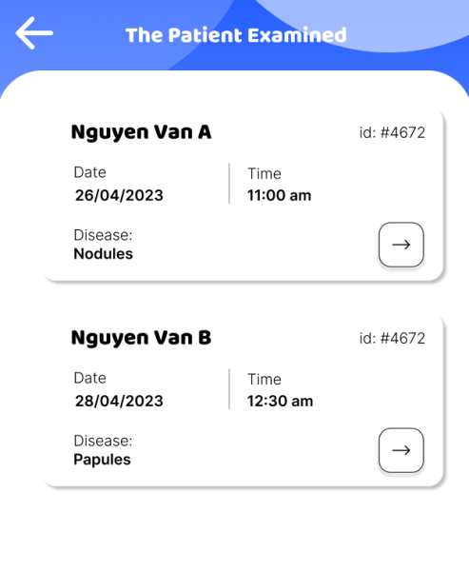
Figure 106. Patient examined screen

